Project Report

|  |  |
| --- | --- |
| Project Title | Design, Develop, Implement, Test & Document Used Car Sales Portal Website |
| Qualification Name (NICF) | Advanced Certificate in Software Applications (Development and Process) |
| Product Name | ABC Cars Pte Ltd Portal |
| Module Name (NICF) | Application Development & Process |

|  |  |  |  |
| --- | --- | --- | --- |
| Student name | | Assessor name | |
| Agung Yuda Pratama | |  | |
| Date issued | Completion date | | Submitted on |
|  |  | |  |
|  | |  | |
| Project title | Design, Develop, Implement, Test & Document Used Car Sales Portal Website | | |

|  |
| --- |
| Learner declaration |
| I certify that the work submitted for this assignment is my own and research sources are fully acknowledged.    Student signature: Date: 08-05-2023 |

Content

1. **Project Background**
2. **Project Objectives**
3. **Project Requirement Specifications**
4. **Task 1**
5. **Task 2**
6. **Task 3**
7. **Task 4**
8. **Task 5**
9. **Task 6**
10. **Task 7**
11. **Task 8**

Project Background

This Project is used for the Summative Assessment of student in the Module ‘Application Development & Process’ of the NICF Course “Applied Degree in Software Engineering”. This Project considers the skills required to Design, Implement, Test & Document a website for a Used Car Sales Portal using Spring Framework, MySQL server and test the system by adopting Risk Based Testing (RBT). The Project is Design ABC Cars

ABC Cars has made a request for the development of a used car sales portal that incorporates functional requirements such as user registration, car searches based on make, model, registration, and price, viewing car details post-search, and the ability to log in and post cars for sale. The portal is designed to grant access to two types of users: Users and Administrators. Users will be able to perform the aforementioned functions, update their profiles, book test drives, post bidding prices, and deactivate their car posts. The Administrator's role will encompass the basic functionality of the used car portal and the capability to mark a user as an administrator, approve appointments/bookings based on bidding, and transact sales at the appropriate price.

Project Objective

The following tasks are among the project's objectives:

* To design and implement a website for a Used Car Sales Portal using Spring Framework and MySQL server
* To test the system by adopting Risk Based Testing (RBT) methodology
* To prepare a project report, project presentation, and website documentation as per the pre-defined templates
* To perform all the tasks in the Project Task List
* To develop a Used Car Sales portal where users can register, search for cars, view car information, post a car for sale, book an appointment for a test drive, and post the bidding price
* To develop an Administrator panel where administrators can perform functions such as registering, viewing the list of registered users, activating/deactivating car posts, updating their profile, approving/denying user's appointments based on the bidding, and transacting the sales if the price is right.

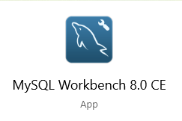**Tools & platform used**

|  |  |
| --- | --- |
| **Software** | **Purpose** |
| Spring Tool Suite | Use of a Java IDE to create a java-based used car sales website |
| MySQL Workbench | Information can be saved and retrieved using a relational database system as needed. |
| Chrome DevTools | Used to evaluate the functioning of developed websites and check them |
| Lamdatest.com | Used to conduct cross-browser testing |
| Ngrok | A tool for creating forwarding URLs for cross-browser testing. |
| Microsoft Word | Used to write Application Development & Process report |





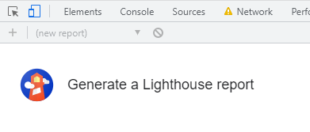

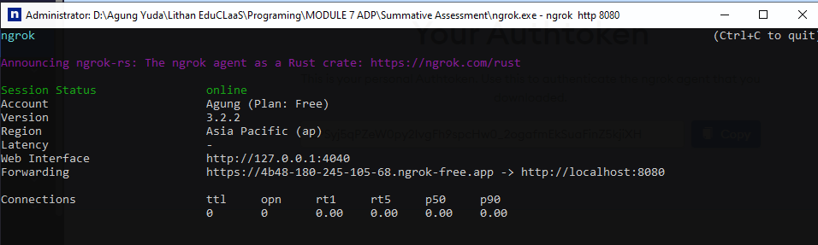

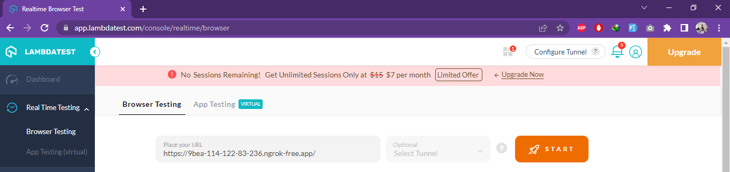

Project Requirements Specifications

* 1. Project Scope

There are 2 types of users in this Used Cars Sales portal. They are

* Users
* Administrator

User

1. Register Page
2. Login Page
3. Post the Car for sale
4. View Car Details
5. Visit Home Page
6. View Car Listing
7. Search Car by make, model, registration & Price Range
8. Bid for the car
9. View About Us Page
10. View Contact Us Page
11. Logout

Admin

1. Login into administrator panel
2. Manage Car
3. Logout
4. Visit Home Page
5. View Car Listing
6. View About Us Page
7. View Contact Us Page
8. Search Car by make, model, registration & Price Range

3.2 Functional Requirement

The following pages will be developed and displayed in the project:

1. Registration Page
2. Login Page
3. About Us Page
4. Home Page
5. Post Car Page
6. Car List Page
7. Biding Page

Task 1

Task Statement:

Create the following items Under “Business Process Section” in Project Presentation

1. Explain the Business Processes the Software is supporting
   1. Document 2 Business Process
2. Document 2 Module functionality
   1. UI Screenshots
   2. Functionality of each of the Screen

Solution:

* 1. Explain the Business Processes the Software is supporting
  2. Document 2 Business Process
     1. Scenario 1 - Post Car

1. To access the used car sales platform, type http://localhost:8080 into your browser.

2. To register as a new user, click "Register" and provide your name, username, email address, and password.

3. A registration success message with a link to the login page will be displayed to the user. 4. On the login page, enter your registered username and password.

5. Following that, the user will view the main page with a list of all the cars listed by other users.

6. To list a car for sale, click "Sell Now" on the homepage, enter the vehicle's name, model, price, make, year, registration date, and a photo, and then click "Post."

7. A post success message with a link to the automobile detail page will be visible to the user.

* + 1. Scenario 2- Search Car

1. To access the used car sales platform, type http://localhost:8080 into your browser.

2. To register as a new user, click "Register" and fill out the required fields (name, username, email, and password).

3. The user will get a notice that says "Register Success" and a link to the login page. 4. Log in using your registered username and password.

5. The user will next see the homepage, which includes a list of all the cars listed by other users.

6. The user can look for an automobile by using the search bar in the header.

7. The user can look up cars by make, model, price, and registration

8. Click "search" and type "car make year 1967"

9. The user will see a page with all of the cars listed that match the search term.

* 1. Document 2 Module functionality
  2. *UI Screenshots*
  3. Post Car

Click Here to Post Your Car

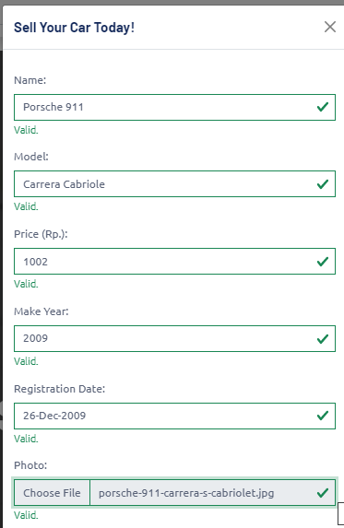

Fulfill the form and click Post



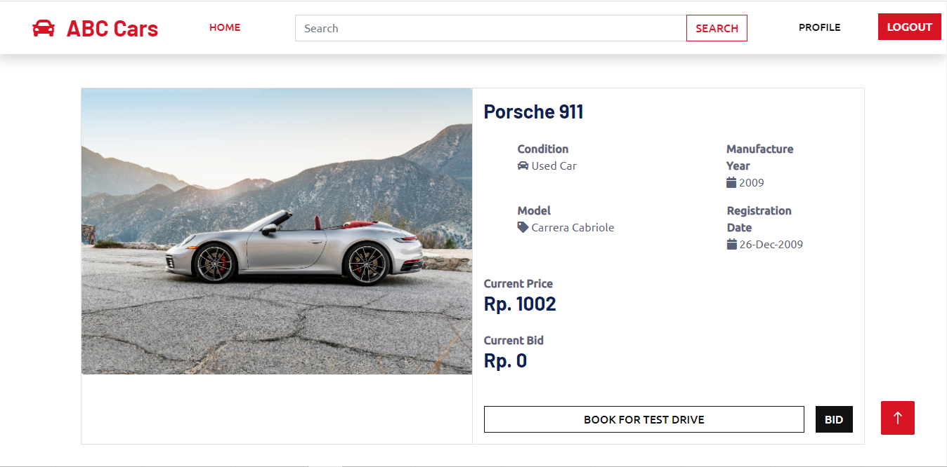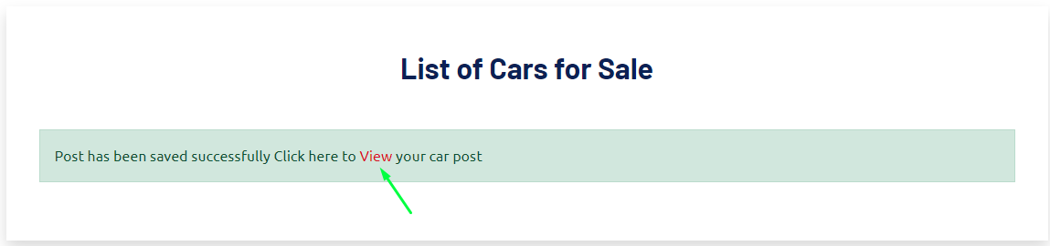

Click View to see The Post

* 1. Search Car
  2. *Functionality of each of the Screen*

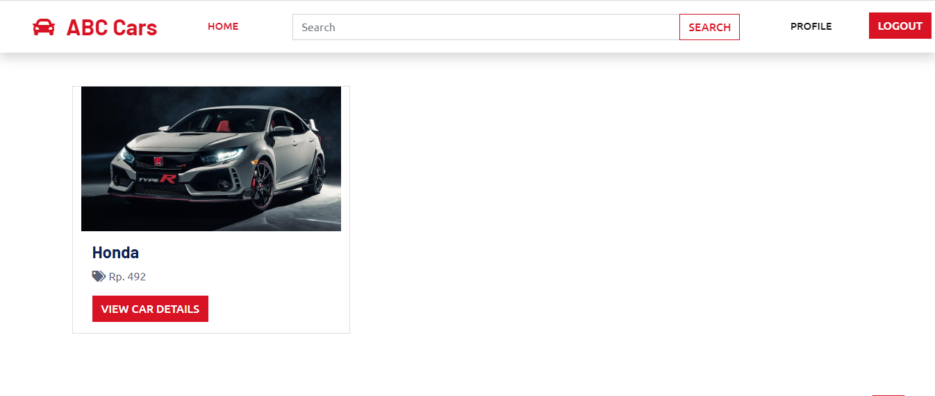

|  |  |
| --- | --- |
| Pages | Functionality |
| Car Post | Users can post a car for sale and can see the post. |
| Car Search | Users can search for a car by make, model, name, or price of Car. |

Task 2

Task Statement:

Create the following items in “Project Plan in Project Presentation

1. Detail the Software Development Methodology to be used for developing system
2. List the various tasks to be done during various phases
3. Create the Project Plan detailing the various steps to be carried out along with dates and Timelines

Solution:

* 1. Detail the Software Development Methodology to be used for developing system

Spiral model.

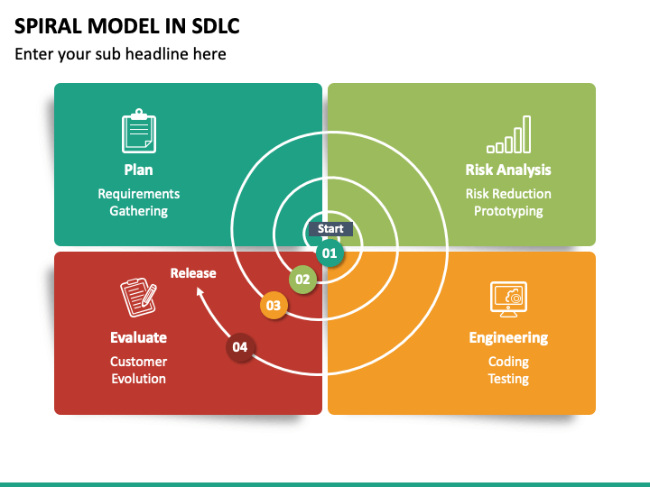

The spiral model is a development model that combines aspects of both iterative and waterfall models. The diagram demonstrates that the phases do not overlap and each phase must be completed before moving on to the next one. However, changes can be made at each iteration. This model is ideal because it supports risk management by including a risk analysis phase. By developing the used car sales portal in a systematic way with features such as registration, login, and searching being added one by one, the development process will be quicker. If a customer is unsatisfied with a particular function, such as registration, changes can be made in the development and testing phase until the customer is satisfied. The spiral model also has other benefits, such as making cost estimation easier as the prototype is developed in small components. For instance, the registration function must be completed first, followed by other functions like login or posting only after successful evaluation. This approach results in less cost estimation for development in each cycle.

* 1. List the various tasks to be done during various phases

### Planning & Requirements Gathering

* 1. Schedule a meeting with the client to learn about their needs for the website.
  2. Prepare the Statement of Work (SOW), also known as the scope document, which details all the conditions anticipated by the customer.
     1. Scope
        1. To design and develop, implement, test & document used car sales portal website
  3. Prepare the Project Initiation Document (Project Initiation Documents)
     1. Set Project Objective
        1. To design, and develop a used car sales portal using Spring Boot framework, Spring Security, Spring Data, JPA and MySQL server.
        2. To deploy the Risk Based Testing (RBT) strategy or spiral SDLC model on the used vehicle sales portal to create the testing plan for verifying the customer requirements.
        3. To record and execute the necessary testing under RBT while documenting the spiral model-based used car sales portal website.
        4. To identify and analyze the risks associated with the used car sales portal and solve the problems based on the RBT test plan.
     2. Estimate Project Cost
        1. Construct a Cost-Benefit Analysis for the used car sales portal
     3. Resource Planning
        1. Acquire guidance from stakeholders, team members, and project managers on the estimated number of resources or refer to published reports on the number:
           1. How many resources are required for the project to develop a used Car portal?
           2. What abilities are important to the project?
           3. Is my resource capacity sufficient?
           4. Prepare the Project Plan Document (PPD)

Finalize the schedule

Grant the chart to visualize the used Car portal timeline.

* + - * 1. Prepare the System Requirement Specification (SRS) document

Define used Car portal purpose based on SOW and project initiation document

Provide specific requirements for:

Functional requirement

User should be able to register and create a new account in the used car portal

User should be able to log in to the car portal

Non-Functional requirement

Security

Performance etc.

### Risk Analysis

* + - * 1. Prepare a Risk Management Plan Document

Schedule a meeting to determine probable risks. The risks involved and a risk breakdown structure (RBS) list for the used car portal.

Prepare a risk analysis chart or risk strategy and assess the risk –

Qualitative risk analysis chart

Prepare a risk mitigation plan – mitigate the risk and report the risk

Prepare a contingency plan – mitigate the unexpected risk predicted to be rarely occurring, for example, backing up website data in case the used car portal was hacked

### Development & Testing

* + - * 1. Prepare the System Design Document

Technical specification

Hardware

Processor: Intel(R) Core(TM) i5-8265U CPU @ 1.60GHz (8 CPUs), ~1.8GHz

RAM: 12 GB

System type: Windows 10 64-bit operating system, x64- based processor

Software

Web server: Apache server

Web browser: Google Chrome

Development environment: JDK 17

Framework: Spring 2.7.11

Database

Database server: MySQL

Database scripting: SQL script

Database client: MySQL Workbench

User Interface

Wireframes

Registration page

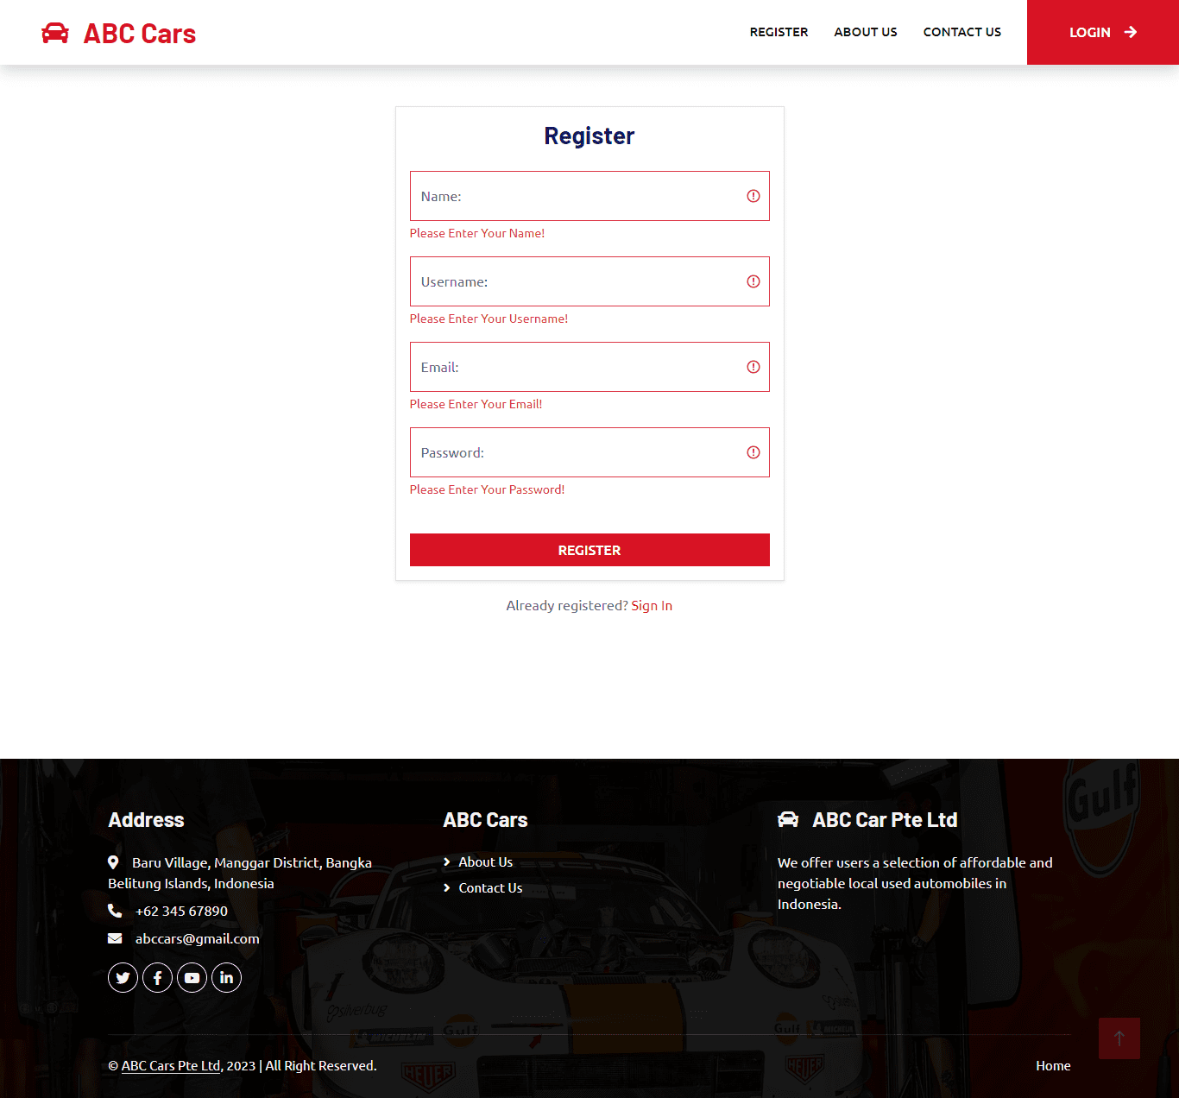

*Wireframe for registration page*

Process Flow

Storyboard

1. Database Design
   1. Entity-Relationship Diagram
   2. Logical Diagram
2. Prepare a software development document
   1. Front-End implementation
      1. Document all JSP pages source code
      2. Document all CSS pages source code
   2. Database implementation
      1. Document DB Schema
   3. Prepare integration document
      1. Business logic implementation
         1. Define the business rules
            1. Only the User can post a car for sale
            2. Define the data exchange method from the database to user interface

Direct database connection using JSP

* 1. Prepare test case document
     1. Define the test case for unit testing
        1. Validate registration function

1. Conduct unit testing
   1. Review the test case
   2. Run the test cases
   3. Record the result
      1. Compare expected to the actual result
      2. Record the result status as either successful or fail
   4. Check the accuracy and debug
   5. Make relevant changes to the front-end web pages
   6. Conduct user acceptance testing (UAT) with the client
      1. Define the UAT test case
      2. Run the UAT test case
      3. Record the result

### Evaluation

* + - 1. Prepare website demo for the customer
      2. Retrieve feedback from customers and satisfaction
      3. Make changes to the website based on customer feedback by going back to the development and testing phase if customer approval is not achieved
      4. Proceed to the next phase of planning after customer approval until the website is fully developed
      5. Confirm website has been developed as per the SRS document
      6. Project sign-off between client and project manager
      7. Product ready for deployment
      8. Upload developed used car website on the web server
  1. Create the Project Plan detailing the various steps to be carried out along with dates and Timelines

|  |  |  |  |  |
| --- | --- | --- | --- | --- |
| S.No. | Phases | Activity | Start Date | End Date |
| 1. | Planning | Arrange a meeting with the client to  gather the business requirement for the website | 20-04-2023 | 20-04-2023 |
|  |  | Prepare the Statement of Work (SOW) – Project scope | 20-04-2023 | 20-04-2023 |
|  |  | Define Project Objective | 20-04-2023 | 20-04-2023 |
|  |  | Estimate Project Cost | 20-04-2023 | 20-04-2023 |
|  |  | Resource Planning | 20-04-2023 | 20-04-2023 |
|  |  | Finalize the schedule | 21-04-2023 | 21-04-2023 |
|  |  | Prepare System Requirement Specification (SRS) document. | 21-04-2023 | 21-04-2023 |
| 2. | Risk Analysis | Arrange a meeting to identify potential risk, the type of risks involved in the used car sales portal | 21-04-2023 | 21-04-2023 |
|  |  | Prepare risk strategy & assessment – Qualitative risk analysis chart | 21-04-2023 | 21-04-2023 |
|  |  | Mitigate the risk | 21-04-2023 | 21-04-2023 |
| 3. | Development & Testing | Define Technical specifications | 22-04-2023 | 22-04-2023 |
|  |  | Prepare user interface | 22-04-2023 | 24-04-2023 |
|  |  | Prepare database design | 22-04-2023 | 23-04-2023 |
|  |  | Front-end implementation | 23-04-2023 | 26-04-2023 |
|  |  | Database implementation | 23-04-2023 | 24-04-2023 |
|  |  | Business logic implementation | 23-04-2023 | 25-04-2023 |
|  |  | Prepare test cases for testing. | 24-04-2023 | 26-04-2023 |
|  |  | Conduct testing | 24-04-2023 | 27-04-2023 |
|  |  | Record testing result | 24-04-2023 | 27-04-2023 |
|  |  | Check accuracy and debug | 25-04-2023 | 27-04-2023 |
|  |  | Make relevant changes to the front-end. | 25-04-2023 | 27-04-2023 |
| 4. | Evaluation | Prepare website demo for customer | 28-04-2023 | 29-04-2023 |
|  |  | Retrieve feedback from customers and satisfaction. | 29-04-2023 | 29-04-2023 |
|  |  | Project sign-off between client and project manager | 01-05-2023 | 01-05-2023 |
|  |  | Used car sales portal ready for deployment | 01-05-2023 | 01-05-2023 |

Task 3

Explain risk-based testing concepts and requirements with the following details

Solution:

* 1. Stages involved in RBT model
     1. What is the risk?

The occurrence of an uncertain or unexpected event is a common concern in project management. Such events may positively or negatively impact a project's objectives, including its budget, business, technical, performance, and quality objectives. The likelihood of the occurrence or change of a particular set of circumstances may be difficult to determine, as it might happen in the past or current, or may happen in the future. Therefore, project managers must anticipate potential risks and plan for contingencies to minimize their impact on the project's overall success. This involves identifying and analyzing risks, developing appropriate risk management strategies, and continuously monitoring and controlling risks throughout the project's lifecycle. By doing so, project managers can improve their chances of delivering the project on time, within budget, and to the required level of quality.

* + 1. RBT stages

Risk identification: Risk-based testing (RBT) is a testing approach using the risk management process.

* + - 1. Risk Identification

Various ways to identify risk includes:

* + - * + Brainstorming
        + SWOT Analysis
        + Risk Checklist
        + Cause & effect diagram and etc.

The risk can also be categorized into 3 categories of:

* + - * + Known risk

1. Functional risk
2. Non-functional risk
3. Technical risk
   * + - * Unknown risk: Appear during testing

Example:

1. Insufficient resources
2. Testing was delayed because a fault appeared suddenly.
   * + - * Unknowable risk: not anticipated and having critical impact

Example:

1. System down for more than 1 day
2. Natural calamities
   * + 1. Risk Strategy & Assessment

The risk matrix, a quantitative risk analysis technique, will examine and quantify identified risks further. The risk matrix displays the risk's likelihood and magnitude or impact. With values ranging from low to excessive, quantified risk is assigned in order to provide a clear understanding of the different risks found.

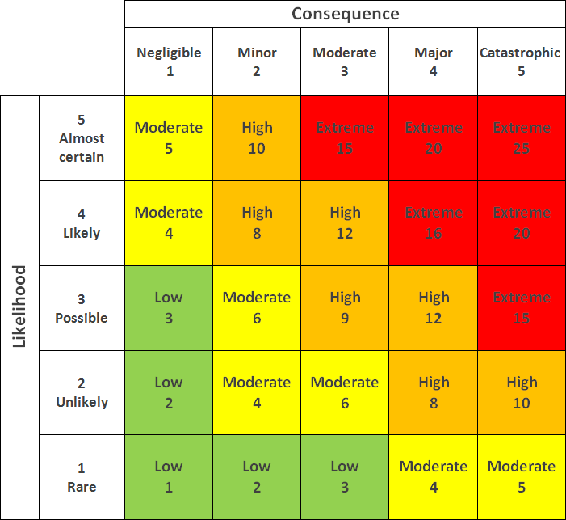 *Risk Matrix*

* + - 1. Risk Mitigation

If the risk could not be entirely eliminated, the way to eliminate the risk or decrease its significant impact can be done by basing on the response plan below to the degree of an acceptable level.

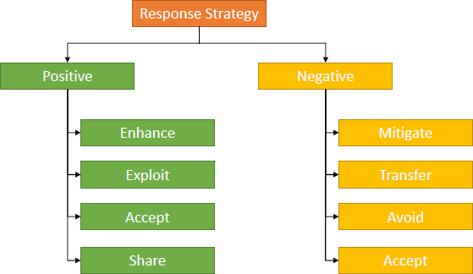

*Response strategy to mitigate risk*

* + - 1. Risk Monitoring and Control

Monitoring and controlling risks includes discovering new risks, keeping tabs on existing risks, and more. Risk may rise for a number of reasons, such as the rapid pace of technological advancement, the scale and scope of the project, or a skills gap. Therefore, ongoing monitoring can be carried out through risk assessments, audits, trend analysis, or status update meetings to measure the success of risk reduction.

3.1.3 Eight characteristics of Software Product Quality

*<*The learner needs to follow ISO standards (ISO/IEC 25010:2011) to create test cases>

**

Definition of each characteristics :

1. Functional suitability – How the software meets specified functional requirements and user objectives.
2. Performance efficiency - the performance relative to the amount of resources used under stated conditions.
3. Compatibility - the degree to which the software can be used with different hardware, software, or other systems.
4. Usability – Is the software is easy to learn, operate, and understand or not.
5. Reliability - the degree to which the software can perform its required functions under stated conditions for a specified period of time.
6. Security - the degree to which the software protects information and data from unauthorized access and other security risks.
7. Maintanability - the degree to which the software can be modified and maintained, and the effort required to do so.
8. Portability - the degree to which the software can be transferred from one environment to another.
   1. Types of Risk

|  |  |  |  |
| --- | --- | --- | --- |
| Type of risk | Risk identification | Risk description | Impact |
| Functional | Login risk | The user is not able to log in | Users won't be able to access all the functions the website offers if they cannot log in. |
|  | Searching risk | The user is not able to search for a car | The user must search manually to find a specific car because it is difficult to do so through the portal. |
|  | Posting a car risk | The user is not able to post his car | The user is not able to post a car to sale his car in the portal |
|  | Viewing car detail risk | The user is not able to view selected car details | The user is not able to bid, book, and see the details for a particular car |
|  | Data is not saved, deleted, or updated in the database | No rows were affected during the operation | Some features or even the entire application will not work properly |
| Non-Functional Risk | Performance | The home page is not loading in the expected time | The user will lose interest and lose patience to wait, and finally, the user will choose another website that meets the user’s needs |
|  | Compatibility | The home page has a different look and feel in different browsers | Users will lose interest due to the difference of user interface |
|  | Maintainability | Used car portal cannot be modified or make changes | Users will judge the portal as not up to date |
|  | Usability | The portal has no clear labeling or usage instructions, making it difficult to explore. | The software may be challenging for users to understand and operate, which could cause dissatisfaction and eventual product desertion. |
| Technical Risk | Security | The user is not authenticated correctly after logging in | The user will not be able to log in to the portal and reach the home page |
|  |  | Navigation is not properly authorized based on the user's login role assigned. | The user will have unauthorized access to sensitive information or functionality. |
|  |  | SQL injection | It might result in sensitive data loss, data breaches, and system integrity issues. |
|  | Portability | Used car sale portal look and feel is different in phone/mobile devices | Users who are comfortable with a certain gadget will stop using the website. |

1. Task 4

Task Statement

Create the following items under “Test Planning” in Project Report

1. Establish the test phases of security testing with its prioritization
2. Develop the detailed test plan with test cases based on quantitative risk analysis
3. Create a test risk matrix with the evaluation of the impact

Solution

1. Establish the test phases of security testing with its prioritization.

(a) RBT Test Strategy in car portal project

1. What is security testing?

Software testing that focuses on finding vulnerabilities and faults in a system or application's security mechanisms is known as security testing. To ensure that the system or application is protected against potential threats including unauthorized access, hacking, data breaches, and other cyber-attacks, security testing is conducted.

2. Types of Security Testing

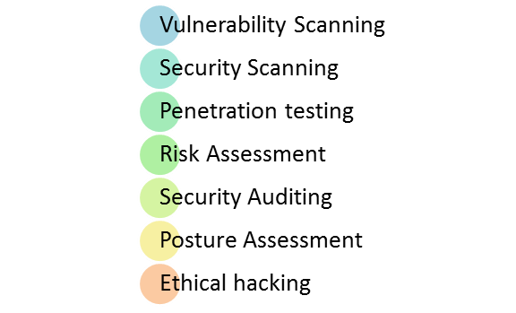

* Vulnerability scanning: identify known vulnerabilities in the system or network.
* Security scanning: This can be done manually or using automated technologies to find system and network vulnerabilities and lower the risk.
* Penetration testing: An external attack simulation identifies potential vulnerabilities in the system or network.
* Risk assessment: This entails assessing security threats, categorizing them as low, medium, or high, and selecting countermeasures.
* Security auditing: Inspecting the code line by line to identify security flaws.
* Posture assessment: Ethical hackers are employed to identify security flaws in the system.
* Ethical hacking: To determine an organization's total security posture, security scanning, ethical hacking, and risk assessment are combined.

**(b) Among test strategies, how to carry security testing.**

The ABC Cars Project’s Security Testing Process

Risk assessment identifies, evaluates, and analyzes potential risks that could affect an organization's operations, assets, or objectives. Risk assessment aims to identify potential threats and vulnerabilities that could impact the organization and determine the likelihood and impact of these risks. The process involves several steps:

1. Risk Identification: Identifying potential organizational risks, such as cyber-attacks, natural disasters, or other security incidents.
2. Risk Analysis: This step involves assessing the likelihood and impact of each identified risk. The likelihood is determined by considering the probability of the risk occurring, while the impact is determined by considering the potential consequences of the risk.
3. Mitigating the risk: This step involves developing strategies to manage and mitigate identified risks.

**(c) Test phases in security testing**

Security testing is crucial in every software development life cycle (SDLC) phase to ensure the final product is secure.

1. Requirement phase: conduct a security analysis to check for potential misuse cases that could pose a security risk.
2. Design: identify potential security issues and plan for how to address them.
3. Coding and Unit testing: should be conducted by testers who have knowledge of the internal structure of the website code.
4. Integration testing: test the website’s functionality without considering the internal system design.
5. System testing: testing and vulnerability scanning should be conducted to identify any potential vulnerabilities in the complete website.
6. Implementation: penetration testing should be conducted to simulate an attack from a malicious hacker, along with vulnerability scanning.
7. Support: patches and software updates should be implemented to address any vulnerabilities identified during testing.

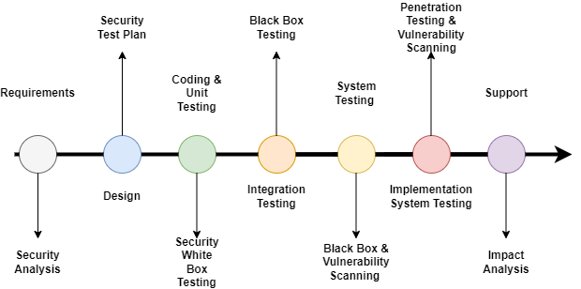



* 1. Develop The Detailed test plan with test cases based on quantitative risk
     1. The testing plan for the used car portal includes the following testing

1. Functional Testing - UAT test cases - 5 atleast
2. Compatibility - Cross-browser testing / responsiveness
3. Performance Efficiency - Load Testing/ Stress testing
4. Usability testing - Prototyping
5. Security - Security testing (IU 5) / Spring Security (Priority Testing)
6. SQL injection
7. Logging
8. Authentication and Authorization
9. Portability - Multi platforms (different platforms, different devices)
10. Reliability – same with usability testing
11. Maintainability – Using Spring (Dependency Injection), Junit Testing
    * 1. Test Plan Table

The test plan includes the following:

1. Test Scenario
2. Test Cases (Under one scenario, there may be more than one test cases)
3. Test Objectives
4. Expected Outcome
5. Risk
6. Techniques (Types of testing)

|  |  |  |  |  |  |  |  |
| --- | --- | --- | --- | --- | --- | --- | --- |
| Risk Id | Test Scenario ID | Test Scenario | Test Objective | Test Priority | Risk | Technique | Expected Results |
| 1 | UA001 | Ensure user can register in the portal | To allow user to register with their credentials (name, username, email, password) successfully | High | User is not able to register with their credentials | UAT Testing | After registering user will see the succes message and their credentials saved in the database |
| 2 | UA002 | Ensure user can login in the portal | To allow user to login with registered credentials | High | User is not able to log in with registered credentials | UAT Testing | After login, user will reach to the home page |
| 3 | UA003 | Ensure user car post a car in the portal | To allow user to post a car in the portal | High | User is not able to post a car in the portal | UAT Testing | Users can post their car in the portal |
| 4 | UA004 | Ensure user can search and view car detail | To allow user to search a particular car in the portal | High | User is not able to find the expected car | UAT Testing | After giving the keyword user will see matched search result |
| 5 | UA005 | Ensure user can update his profile | To allow user to update their profile | High | Users is not able to update their profile | UAT Testing | Users can see updated details in their profile |
| 6 | TS001 | Validating registration functionality | To check registed data stored successfully | High | User is not able to register in the portal | Unit Testing | After checking, junit should return a passing result as user data can be save |
| 7 | TS002 | Validating login functionality | To check credentials are existing in the system | High | User is not able to log in to the portal | Unit Testing | After checking, junit should return a passing result as user data exist/presen t in the system |
| 8 | TS003 | Ensure car can be added/ saved | To test posting a car | High | User not able to post a car | Unit Testing | After checking, junit should return a passing result as car data can be saved |
| 9 | TS004 | Checking search functionality | To test searching functionality | High | User not able to find a car | Unit Testing | After checking, junit should return a passing result as any car can be search with matching requirement s |
| 10 | TS005 | Ensure the functionality of bidding price for a selected car | To test adding a bid worked properly | High | User not able to bid for a car | Unit Testing | After checking, junit should return a passing result as Project Report NICF Capstone Project using Java Page | 28 bidding data can be save |
| 11 | PM001 | Testing the performance of registration page | To utilize the page’s loading speed of the registration page using Chrome DevTools | Extreme | User will lose interest and does not want to use the application | Performance Testing | After testing, The loading time speed should be above 80 – 90% or less than 1s. |
| 12 | CB001 | Ensure register page maintain a consistent look and feel in different browser (Chrome, Edge, Firefox) | To check a consistent look and feel of the register page across different browser | High | User may feel irritated with the different look and feel in the register page and lose credibility on the portal | Compatibility Testing | After testing, register page maintain a consistent look and feel across different browser |
| 13 | CB002 | Ensure login page maintain a consistent look and feel in different browser (Chrome, Edge, Firefox) | To see a consistent look and feel of the login page across different browser | High | User may feel confused with the different look and feel in the login page and lose credibility on the portal | Compatibility Testing | After testing, Register page should have consistent look and feel across different browser |
| 14 | CB003 | Ensure home page maintain a consistent look and feel in different browser (Chrome, Edge, Firefox) | To see a consistent look and feel of the home page across different browser | High | User may feel confused with the different look and feel in the home page and lose credibility on the portal | Compatibility Testing | After testing, home page should have consistent look and feel across different browser |
| 15 | CB004 | Ensure car detail page maintain a consistent look and feel in different browser (Chrome, Edge, Firefox) | To see a consistent look and feel of the car detail page across different browser | High | User may feel confused with the different look and feel in the car detail page and lose credibility on the porta | Compatibility Testing | After testing, car detail page should have consistent look and feel across different browser |
| 16 | CB005 | Ensure profile page maintain a consistent look and feel in different browser (Chrome, Edge, Firefox) | To see a consistent look and feel of the profile page across different browser | High | User may feel confused with the different look and feel in the profile page and lose credibility on the porta | Compatibility Testing | After testing, profile page should have consistent look and feel across different browser |
| 17 | PB001 | Ensure register page maintain a consistent look and feel in different devices (laptop, iPad, phone) | To ensure all feature in the register page is visible to the user in different devices | High | User may lose interest and chose a different option as the website are not able to adapt to their device of choice | Portability Testing | After testing, all register page is visible to the user in different devices (laptop, iPad and phones) |
| 18 | UB001 | Test whether the register page is userfriendly in design | To ensure all navigation in header and footer works properly and the content is visible | High | User will be unable to fully utilize the function in the register page | Usability Testing | User will be able to use all navigation links in the register page properly and understand the flow of features available |
| 19 | UB002 | Test whether the login page is userfriendly in design | To ensure all navigation in header and footer works properly and the content is visible | High | User will be unable to fully utilize the function in the login page | Usability Testing | User will be able to use all navigation links in the login page properly and understand the flow of features available |
| 20 | UB003 | Test whether the home page is userfriendly in design | To ensure all navigation in header and footer works properly and the content is visible | High | User will be unable to fully utilize the function in the home page | Usability Testing | User will be able to use all navigation links in the home page properly and understand the flow of features available |
| 21 | UB004 | Test whether the car detail page is userfriendly in design | To ensure all navigation in header and footer works properly and the content is visible | High | User will be unable to fully utilize the function in the car detail page | Usability Testing | User will be able to use all navigation links in the car detail page properly and understand the flow of features available |
| 22 | UB005 | Test whether the profile page is userfriendly in design | To ensure all navigation in header and footer works properly and the content is visible | High | User will be unable to fully utilize the function in the profile page | Usability Testing | User will be able to use all navigation links in the profil page properly and understand the flow of features available |
| 23 | SE001 | Ensure user is authentica ted correctly after logging in | To ensure Spring Security login feature is authenticated correctly | High | User will not be able to log in to the portal and reach the home page | Security testing | User will be able to reach respective home page based on role assigned |
| 24 | SE002 | Ensure after logging in, user home page navigation is authorized correctly based on role assigned | To ensure Spring security authorization is working correctly on the navigation bar | Extreme | User with role assigned could not fully utilize feature based on assigned role and expose all user’s data to unauthorize d access compromisi ng user confidentiali ty | Security testing | User with user role can post car and buy car while user with administrato r role can manage user and car data |
| 25 | SE003 | Checking for SQL injection | To ensure search input data is not vulnerable to an SQL injection | Extreme | User with ill intent will be able to access database data and retrieve sensitive information | Security testing | No return is given as a result from the injected SQL Query |

**3. Create a test risk matrix with the evaluation of the impact**

1. How Risk Evaluation is conducted.

## Quantitative Risk Analysis

1. Identify risk related to ABC used car portal
2. Calculate the risk by multiplying the likelihood by the consequences

𝑅𝑅𝑅𝑠𝑘 = 𝐿ik𝑒lilh𝑜𝑜𝑑 𝑥 𝐶𝑜𝑛𝑠𝑒𝑞𝑢𝑒𝑛𝑐𝑒

𝑅𝑅𝑅𝑠𝑘 = 2 𝑥 4 = 8

1. Develop a test Risk Matrix for a given specification.

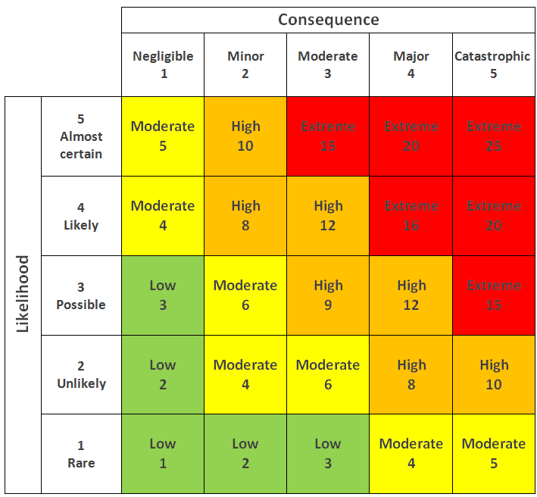

|  |  |  |  |  |  |  |
| --- | --- | --- | --- | --- | --- | --- |
| Risk ID | Risk | Likelihood  (1-5) | Impact  (1 – 5) | Type of  Testing | Risk  Rating | Risk Level |
| 1 | User is not be able register in the system | 3 | 4 | UAT Testing | 12 | High |
| 2 | User will not be able to reach the portal home page to post or view cars | 3 | 4 | UAT Testing | 12 | High |
| 3 | User will not be able to sell their car | 3 | 4 | UAT Testing | 12 | High |
| 4 | User will not be able to find the car expected | 3 | 3 | UAT Testing | 9 | High |
| 5 | User will not be able to complete their profile information | 3 | 3 | UAT Testing | 9 | High |
| 6 | User will not be able to login to the portal | 3 | 4 | Unit Testing | 12 | High |
| 7 | User will not be able to register in the portal | 3 | 4 | Unit Testing | 12 | High |
| 8 | User will not be able to post a car in the portal | 3 | 4 | Unit Testing | 12 | High |
| 9 | User will not be able to search for any car | 3 | 3 | Unit Testing | 9 | High |
| 10 | User will not be able to bid for any car | 3 | 4 | Unit Testing | 12 | High |
| 11 | User will lose interest and will not register to login and access the home page to buy or sell car | 4 | 4 | Performance Testing | 16 | Extreme |
| 12 | User may feel irritated with the different look and feel in the register page and lose credibility on the portal | 3 | 3 | Compatibility Testing | 9 | High |
| 13 | User may feel irritated with the different look and feel in the login page and lose credibility on the portal | 3 | 3 | Compatibility Testing | 9 | High |
| 14 | User may feel irritated with the different look and feel in the home page and lose credibility on the portal | 3 | 3 | Compatibility Testing | 9 | High |
| 15 | User may feel irritated with the different look and feel in the car detail page and lose credibility on the portal | 3 | 3 | Compatibility Testing | 9 | High |
| 16 | User may feel irritated with the different look and feel in the profile page and lose credibility on the portal | 3 | 2 | Compatibility Testing | 6 | High |
| 17 | User may lose interest and chose a different option as the website are not able to adapt to their device of choice | 3 | 4 | Portability Testing | 12 | High |
| 18 | User will be unable to fully utilize the function in the register page | 3 | 4 | Usability Testing | 12 | High |
| 19 | User will be unable to fully utilize the function in the login page | 3 | 4 | Usability Testing | 12 | High |
| 20 | User will be unable to fully utilize the function in the home page | 3 | 4 | Usability Testing | 12 | High |
| 21 | User will be unable to fully utilize the function in the car detail page | 3 | 4 | Usability Testing | 12 | High |
| 22 | User will be unable to fully utilize the function in the profile page | 3 | 3 | Usability Testing | 9 | High |
| 23 | User will not be able to log in to the portal and reach the home page | 3 | 4 | Security Testing | 12 | High |
| 24 | User with role assigned could not fully utilize feature based on assigned role and expose all user’s data to unauthorized access compromising user confidentiality | 3 | 5 | Security Testing | 15 | Extreme |
| 25 | User with ill intent will be able to access database data and retrieve sensitive information | 3 | 5 | Security Testing | 15 | Extreme |

1. Task 5

Task Statement

Create the following items under “Testing Strategy” in Project Report

1. Design suitable RBT cycle content and priorities further test cycles
2. Communicate the details of the strategy and test planning to the key stakeholders with proper justifications

Solution

**1. Design suitable RBT cycle content and priorities further test cycles.**

Design and explain a suitable risk base test cycle based on your car sale portal project**.**

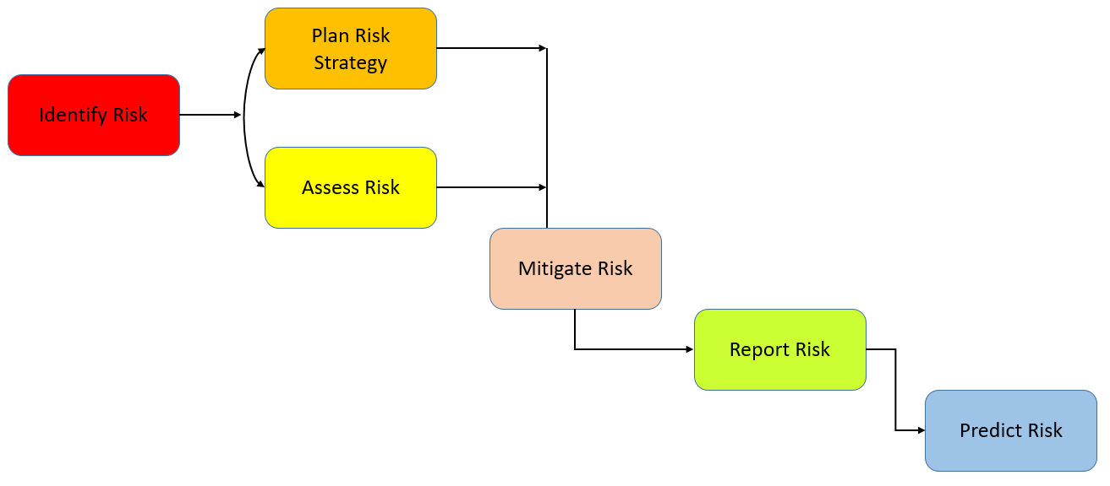

8.1.1 Identify risk

• Make that the needs for the ABC Car portal have been thoroughly assessed based on the customer specification.

• Identifying the risk using multiple techniques by contacting the business and technical team for an interview session to gain information on various risks present for the used car sales portal

• Requesting input from every team member during a brainstorming session on potential risks to the used vehicle sales portal

8.1.2 Plan risk strategy and assess risk

• Creating a Risk Register or putting all identified risks there so they can be classified according to how important they are to the portal

• Create a thorough risk assessment plan for the used car gateway by filtering the risks that have been discovered and taking into account their likelihood and potential effects.

• Prioritize which risks should be tested in the test plan by calculating the risk level using the risk matrix.

• Design test cases and execute them based on the priority of the risk item

• Evaluate the exit criteria ensuring all high-risk items are fully tested only minor residual risk when testing the used car portal

8.1.3 Mitigate risk

• Contacting each stakeholder and setting up meetings to discuss possible solutions to the issue/risk and getting updates on the risk, which has been managed previously for the portal

• Create a centralized system where all risk data are recorded and can become a reference for future management of risk

• Consulting with a risk analyst or an expert to eliminate or contain the risk as much as possible.

8.1.4 Report risk

• Keep a record of the results or log of the risk-based testing for the used car portal and send the report to the development team so they can address the problem with the failed test cases.

8.1.5 Predict risk

• Predict future risk outcomes using the risk assessment, and develop a backup plan to deal with unforeseen situations.

1. Communicate the details of the strategy and test planning to the key stakeholders with proper justifications

* 1. Justify the selection of test methods based on quantified risk to a project.

|  |  |
| --- | --- |
| **Type of Testing** | **Main Purpose** |
| Functional Testing | This testing focuses on validating functions mentioned in the project requirement specification for user and admin, such as login, register, view car’s details, post new car with details, bidding car’s price. |
| Security Testing | This testing will reveal weaknesses, risks, or threats from nefarious intrusions to the used automobile gateway. SQL injection is one type of attack when a hacker inserts a malicious SQL statement into a search bar or other input field to retrieve and update data in the portal database, jeopardizing user data privacy and disclosing the database's design. For users to be given access to just the acceptable links for their assigned job, the Spring Security feature is essential in authenticating or confirming the user during the login stage and guaranteeing proper authorization. |
| Performance Testing | This testing focuses on assessing the speed and responsiveness of the portal web pages, including the signup page, to guarantee a better user experience. |
| Compatibility Testing | Cross-browser testing ensures that the car portal can provide the best possible user experience on any browser and detect compatibility issues with different browsers such as Chrome, Edge, or Firefox. |
| Portability Testing | To ensure the portal's lifetime and capacity to adapt to ongoing change, which necessitates regular updating to reduce costs, this testing examines the portal's adaptability in various commercially available devices, including phones, tablets, and laptops. |

* 1. Communicate the details of your strategy and test planning to the key stakeholders with proper justifications

Asda

* What is a stakeholder?

Stakeholders can be individuals, groups, or organizations that have an influence on a software project, or they may be actively involved or have an interest that may affect the success or failure of the project. They have the authority throughout the project lifecycle and different degrees of responsibility (Paspelava, 2021)

* Why is it important to communicate risk to key stakeholders? (Jarrad, 2019)
  + Promote Accountability

By communicating potential risks to teams and stakeholders, there will be a better understanding of allocating roles and responsibilities to the right people. As a Project manager for a used car portal, it is important to make the right call on the individual who can deal with an issue to ensure the project stays on track.

* + Provide realistic expectations

Transparency in communicating with stakeholders regarding a potential risk will allow them to have an awareness or realistic view of how the risk may affect the project, especially the timeline. Since much finances have been invested by the stakeholders, the right gesture is to be transparent on the current situation, and the stakeholders will likely have more confidence and trust on the project.

* + Unify the team

Proper communication enables a team to respond to risk instantly as there are less confusion and have better understanding on the potential risk. In this way, there is no need for an informant as the information is shared and the issue can be tackled easily.

**Task 6**

Create the following items under **“Testing Results”** in Project Report

1. Execute the risk-based test pan and log the test results

2. Modify the risk-based test procedure with the reasons

## **Execute the risk-based test pan and log the test results**

**Functional Testing (Unit Testing)**

|  |  |  |  |
| --- | --- | --- | --- |
| Requirements | Test Scenario ID | Test Scenario | Number of Test Cases |
| Functional Testing | **TS001 – Unit Testing** | **Validating registration functionality** | 1 |
| **TS002 – Unit Testing** | **Validating Login functionality** | 1 |
| **TS003 – Unit Testing** | **Check if car data can be added/save** | 1 |
| **TS004 – Unit Testing** | **Check if car can be search** | 1 |
| TS005 – Unit Testing | Check if bidding price can be saved | 1 |

|  |  |  |  |  |  |  |  |  |
| --- | --- | --- | --- | --- | --- | --- | --- | --- |
| **Scenario ID** | **Test Case ID** | **Test Case** | **Preconditions** | **Steps** | **Test Data** | **Expected Results** | **Actual Results** | **Pass/Fail** |
| **TS001** | TC001 | Check if registered data can be saved | Implementation of ABC Car Portal is complete with all webpages and navigation links and uploaded on  localhost server | 1. Run Test script shown in screenshot below | Name= Anggun Nazhuha  Username = anggun Email=  [anggun@gmail.com](mailto:%20anggun@gmail.com)  Password= anggun | After checking, junit should return a passing result as user data  can be save | Not as expected, | Fail |

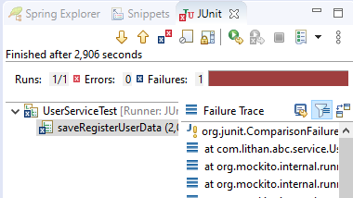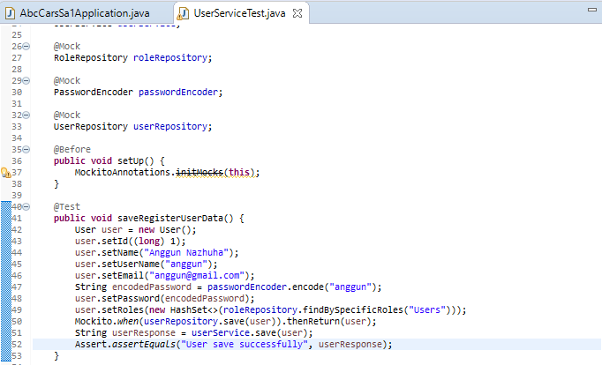

Evidence

JUnit result shows failure in the test case. The result is not as expected.

|  |  |  |  |  |  |  |  |  |
| --- | --- | --- | --- | --- | --- | --- | --- | --- |
| **Scenario ID** | **Test Case ID** | **Test Case** | **Preconditions** | **Steps** | **Test Data** | **Expected Results** | **Actual Results** | **Pass/Fail** |
| **TS002** | TC001 | Check if user credential is existing in the system | Implementation of ABC Car Portal is complete with all webpages and navigation links and uploaded on localhost server | 1. Run Test script shown in screenshot below | Username = anggun | After checking,  junit should return a passing result as user data exist/present in  the system | As expected, | Pass |

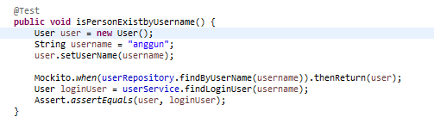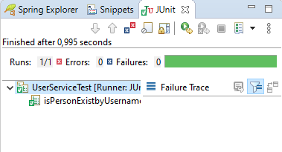

Evidence

|  |  |  |  |  |  |  |  |  |
| --- | --- | --- | --- | --- | --- | --- | --- | --- |
| **Scenario ID** | **Test Case ID** | **Test Case** | **Preconditions** | **Steps** | **Test Data** | **Expected Results** | **Actual Results** | **Pass/Fail** |
| **TS003** | TC001 | Validate if car information can be added successfully | Implementation of ABC Car Portal is complete with all webpages and navigation links and uploaded on localhost server | 1. Run Test script shown in screenshot below | name = Perodua Myvi model= Perodua Price = 33000  Make Year = 2021  Registration Date = Jan 2021 | After checking, junit should return a passing result as car data can be saved | As expected, | Pass |

Evidence

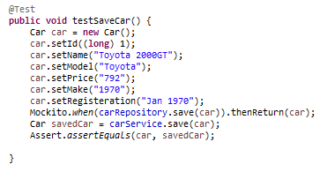

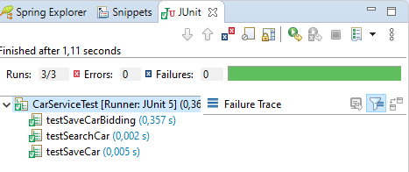

|  |  |  |  |  |  |  |  |  |
| --- | --- | --- | --- | --- | --- | --- | --- | --- |
| **Scenario ID** | **Test Case ID** | **Test Case** | **Preconditions** | **Steps** | **Test Data** | **Expected Results** | **Actual Results** | **Pass/Fail** |
| **TS004** | TC001 | To test searching for a car | Implementation of ABC Car Portal is complete with all webpages and navigation links and uploaded on localhost server | 1. Run Test script shown in screenshot below | Search input = Toyota | After checking, junit should return a passing result as any car can be search with matching  requirements | As expected, | Pass |

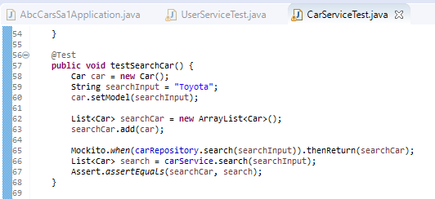 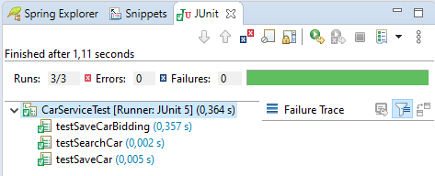

Evidence

|  |  |  |  |  |  |  |  |  |
| --- | --- | --- | --- | --- | --- | --- | --- | --- |
| **Scenario ID** | **Test Case ID** | **Test Case** | **Preconditions** | **Steps** | **Test Data** | **Expected Results** | **Actual Results** | **Pass/Fail** |
| **TS005** | TC001 | To test saving bidding information | Implementation of ABC Car Portal is complete with all webpages and navigation links and uploaded on localhost server | 1. Run Test script shown in screenshot below | Bidding price = 600  Car Name = “Toyota 2000GT”  User name = “Anggun Nazhuha” | After checking, junit should return a passing result bidding information is  saved | As expected, | Pass |
| Evidence |  | | | | | | | |

* + 1. Functional Testing (UAT Testing)

|  |  |  |  |
| --- | --- | --- | --- |
| **Requirements** | **Test Scenario ID** | **Test Scenario** | **Number of Test Cases** |
| **Functional Testing** | UA001 – UAT Testing | Ensure user can register in the portal | 2 |
| UA002 – UAT Testing | Ensure user can login in the portal | 2 |
| UA003 – UAT Testing | Ensure user can post a car in the portal | 2 |
| UA004 – UAT Testing | Ensure user can search a car | 2 |
| UA005 – UAT Testing | Ensure user can update profile | 2 |

|  |  |  |  |  |  |  |  |  |
| --- | --- | --- | --- | --- | --- | --- | --- | --- |
| **Scenario ID** | **Test Case ID** | **Test Case** | **Preconditions** | **Steps** | **Test Data** | **Expected Results** | **Actual Results** | **Pass/Fail** |
| **UA001** | UATC001 | Check all the mandatory fields are entered | Implementation of ABC Car Portal is complete with all webpages and navigation links and uploaded on localhost server | 1. Enter URL localhost:8080 2. Click “Register” on website navigation bar 3. Enter all the fields. 4. Click Register. | Name= Stephen Curry  Username = curry Email= [curry@gmail.com](mailto:curry@gmail.com) Password= curry | After registering, user will see a successful registration message and a login link. | As expected, | Pass |

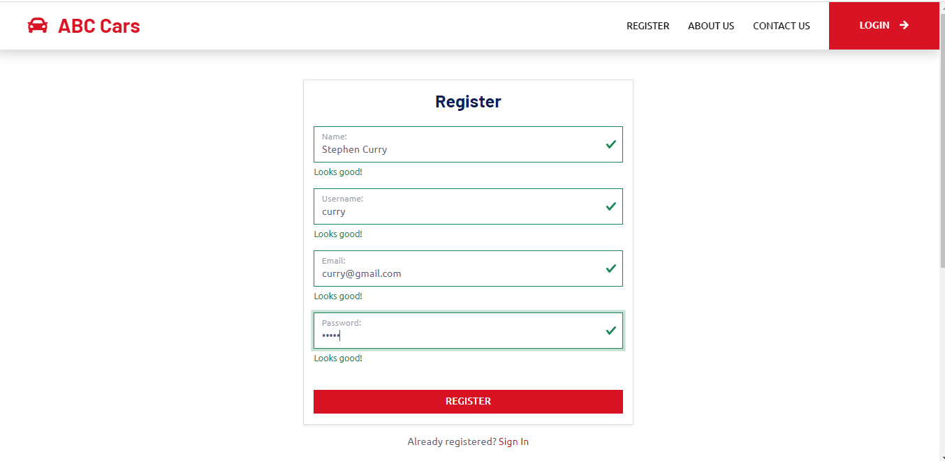

**Evidence**

Enter all fields like name, username, email and password then Register

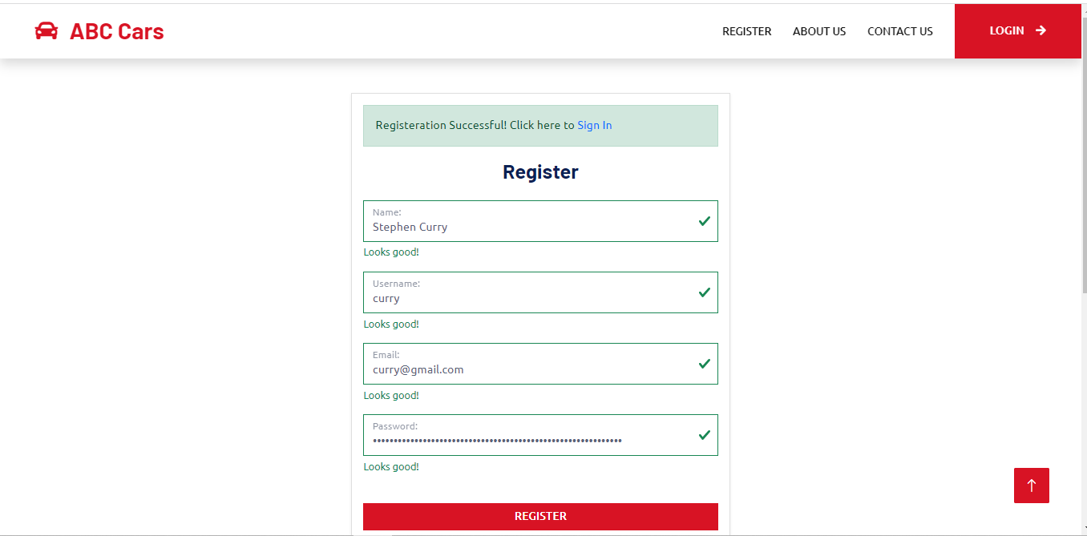

Register success message appear as user has entered valid information

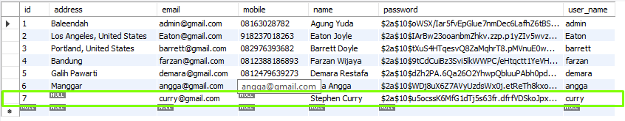

Registered data also added to ‘carsabc database under user table

|  |  |  |  |  |  |  |  |  |
| --- | --- | --- | --- | --- | --- | --- | --- | --- |
| UA001 | UATC002 | Check registration not blank validation working correctly | Implementation of ABC Car Portal is complete with all webpages and navigation links and uploaded on localhost server | 1. Enter URL localhost:8080 2. Click “Register” on website navigation bar   4. Click Register without entering  any information. | Name= Username = Email= Password= | After submitting the register data, user will see the browser default validation message ‘Please fill out this field’ | As expected, | Pass |
| Evidence | User will not be able to register with empty field | | | | | | | |

|  |  |  |  |  |  |  |  |  |
| --- | --- | --- | --- | --- | --- | --- | --- | --- |
| **Scenario Test Test Case Preconditions Steps Test Data Expected Results Actual Pass/Fail ID Case ID Results** | | | | | | | | |
| **UA002** | UATC001 | Check all the mandatory fields are entered | Implementation of ABC Car Portal is complete with all webpages and navigation links and uploaded on localhost  server | 1. Enter URL localhost:8080   1. Enter all the fields. 2. Click Log In. | Username = curry Password= curry | After login, user will reach to the home page | As expected, | Pass |
| **Evidence** | User need to sign in after registration using username and password registered | | | | | | | |

|  |  |  |  |  |  |  |  |  |
| --- | --- | --- | --- | --- | --- | --- | --- | --- |
|  | User will be directed to the home page once login is successful | | | | | | | |
| UA002 | UATC002 | Check login validation working correctly | Implementation of ABC Car Portal is complete with all webpages and navigation links and uploaded on localhost server | 1. Enter URL localhost:8080 2. Enter password incorrectly   4. Click Log In without entering  any information. | Username = curry Password= curry | After login, user will see an error message to try again or register back | As expected, | Pass |

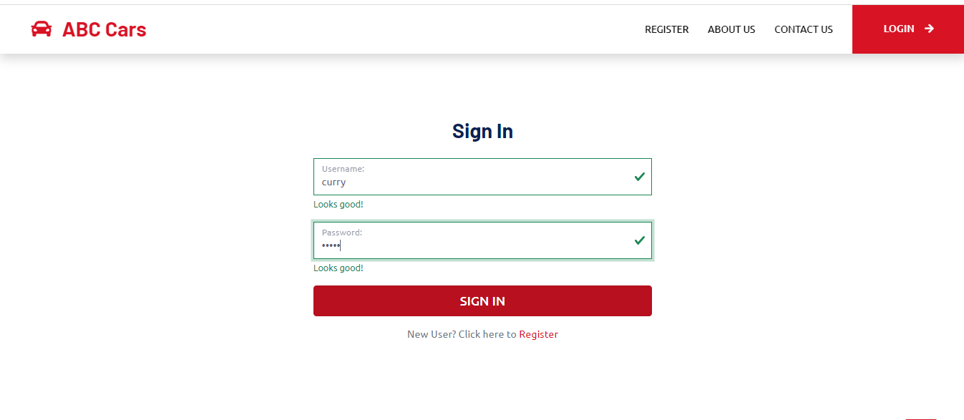 Evidence

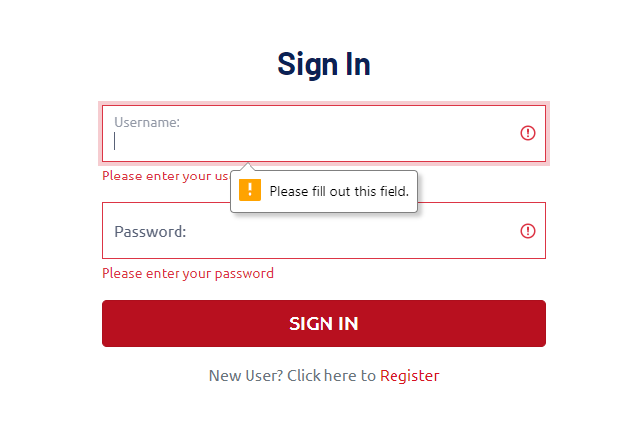

Login error message will appear if username or password entered is not valid or not present in database

|  |  |  |  |  |  |  |  |  |
| --- | --- | --- | --- | --- | --- | --- | --- | --- |
| **Scenario ID** | **Test Case ID** | **Test Case** | **Preconditions** | **Steps** | **Test Data** | **Expected Results** | **Actual Results** | **Pass/Fail** |
| **UA003** | UATC001 | Check if user can successfully post a car in  the portal | Implementation of ABC Car Portal is complete with all webpages and navigation links and uploaded on localhost server | 1. Enter URL localhost:8080 2. Sign In into the portal 3. Click ‘Sell Car’ to post a new car in the home page 4. Enter all the fields. And click post | name = Toyota GT2000  model= Toyota  Price = 900  Make Year = 1970  Registration Date = 07.Dec.1970 | After posting a car, user will see a success message and view car detail  link. | As expected, | Pass |

|  |  |
| --- | --- |
| **Evidence** |  |

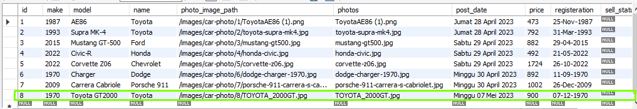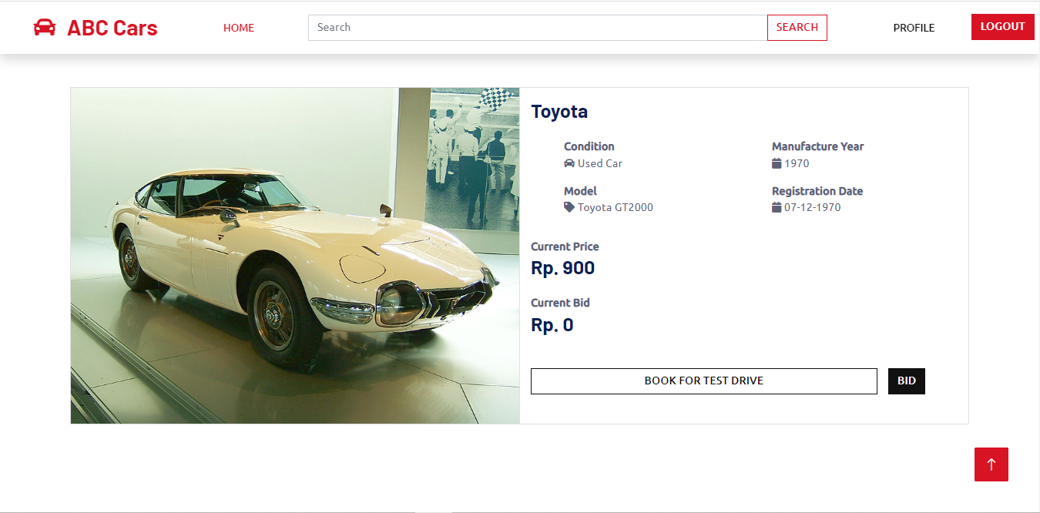

Car detail posted appear in the car detail page

Posted car information is added to ‘carsabc’ database

|  |  |  |  |  |  |  |  |  |
| --- | --- | --- | --- | --- | --- | --- | --- | --- |
| UA003 | UATC002 | Check post car form not blank validation working correctly | Implementation of ABC Car Portal is complete with all webpages and navigation links and uploaded on localhost server | 1.Enter URL localhost:8080 2.Sign In into the portal   1. Click ‘Sell Car’ to post a new car in the home page 2. Click Post without entering any information. | name = model= Price = Make Year =  Registration Date = | After submitting the post data, user will see the browser default validation message ‘Please fill out this  field’ | As expected, | Pass |
| Evidence | User will not be able to post car with an empty field due to browser default validation and form required validation | | | | | | | |

|  |  |  |  |  |  |  |  |  |
| --- | --- | --- | --- | --- | --- | --- | --- | --- |
| **Scenario ID** | **Test Case ID** | **Test Case** | **Preconditions** | **Steps** | **Test Data** | **Expected Results** | **Actual Results** | **Pass/Fail** |
| **UA004** | UATC001 | Check if user can search a car successfully | Implementation of ABC Car Portal is complete with all webpages and navigation links and uploaded on localhost server | 1. Enter URL localhost:8080 2. Sign In into the portal 3. Navigate to home page search bar | Search input = Toyota | After searching, user will see a search result of list of cars matching with the user search input | As expected, | Pass |
|  |  |  |  | 3. Enter search input |  |  |  |  |
|  |  |  |  | 4. Click Search. |  |  |  |  |
| **Evidence** | Car can be search by make, model, registration or price. ‘Toyota’ is the name to be search  List of "Toyota" car mode appear base on the search input | | | | | | | |

|  |  |  |  |  |  |  |  |  |
| --- | --- | --- | --- | --- | --- | --- | --- | --- |
| UA004 | UATC002 | Ensure user can view detail of search car | Implementation of ABC Car Portal is complete with all webpages and navigation links and uploaded on localhost server | 1. Enter URL localhost:8080 2. Sign In into the portal 3. Navigate to home page search bar 4. Enter search input 5. Click Search. 6. Click ‘View Car Details’ on selected   search car result | Search input = Toyota | User can view detail of search car selected | Not As expected | Fail |

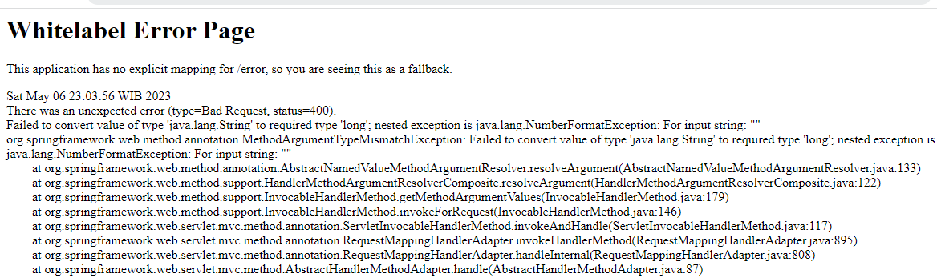

Evidence

|  |  |  |  |  |  |  |  |  |
| --- | --- | --- | --- | --- | --- | --- | --- | --- |
| **Scenario ID** | **Test Case ID** | **Test Case** | **Preconditions** | **Steps** | **Test Data** | **Expected Results** | **Actual Results** | **Pass/Fail** |
| **UA005** | UATC001 | Check if user can update profile successfully | Implementation of ABC Car Portal is complete with all webpages and navigation links and uploaded on localhost server | 1. Enter URL localhost:8080 2. Sign In into the portal 3. Navigate to home page navigation bar and click Profile | Mobile = 0123456789  Address = Malaysia, KL | After updating, user input data mobile and address will appear on their profile page | As expected, | Pass |
|  |  |  |  | 3. Click on the pencil icon next to user image |  |  |  |  |
|  |  |  |  | 4. Enter all field |  |  |  |  |
|  |  |  |  | 5.Click ‘Update’ |  |  |  |  |
| **Evidence** | Click this Icon for editing the profile | | | | | | | |

|  |  |  |  |  |  |  |  |  |
| --- | --- | --- | --- | --- | --- | --- | --- | --- |
|  | Profile is updated  Updated information is also added to ‘carsabc database’ under user table | | | | | | | |
| UA005 | UATC002 | Check update profile form not blank validation working correctly | Implementation of ABC Car Portal is complete with all webpages and navigation links and uploaded on localhost server | 1. Enter URL localhost:8080 2. Sign In into the portal 3. Navigate to home page navigation bar and click Profile 4. Click on the pencil icon next to user image 5. Click ‘Update’ without entering mobile and address fields | Mobile = Address = | After submitting the update profile data, user will see the browser  default validation message ‘Please fill out this field’ | As expected, | Pass |

|  |  |
| --- | --- |
| Evidence | Due to form validation requirements and browser default validation, the user will not be able to update their profile with an empty field. |

* + 1. Performance Testing

|  |  |  |  |
| --- | --- | --- | --- |
| **Requirements** | **Test Scenario ID** | **Test Scenario** | **Number of Test Cases** |
| **Non-Functional Testing** | PM001 – Performance Testing | Testing the performance of registration page | 2 |

|  |  |  |  |  |  |  |  |  |
| --- | --- | --- | --- | --- | --- | --- | --- | --- |
| **Scenario ID** | **Test Case ID** | **Test Case** | **Preconditions** | **Steps** | **Test Data** | **Expected Results** | **Actual Results** | **Pass/Fail** |
| **PM001** | PMC001 | To test the loading time speed of the registration page using Chrome DevTools | Implementation of ABC Car Portal is complete with all webpages and navigation links and uploaded on localhost  server | 1. Enter URL localhost:8080 2. Use Chrome DevTools by right click and choose inspect 3. Click Network, choose No throttling, Fast 3G, Slow 3G |  | After testing,  The loading time is expected to be less than 1s. | As expected, | Pass |
|  |  |  |  | 4. Click “Register” on website |  |  |  |
|  |  |  |  | navigation bar |  |  |  |
| **Evidence** | No throttling selection, result in a finish time of 622 ms. The result is as expected. | | | | | | | |

Fast 3G Selection is finished on 5.06s

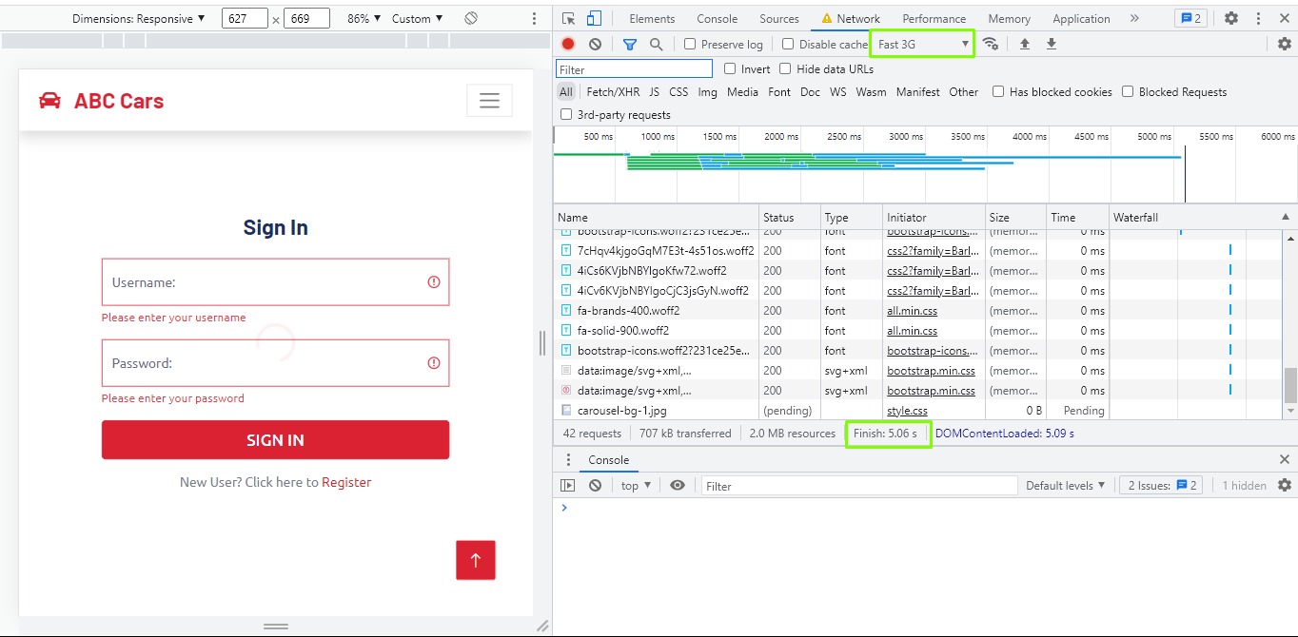

Slow 3G Selection is finished on 18.08s

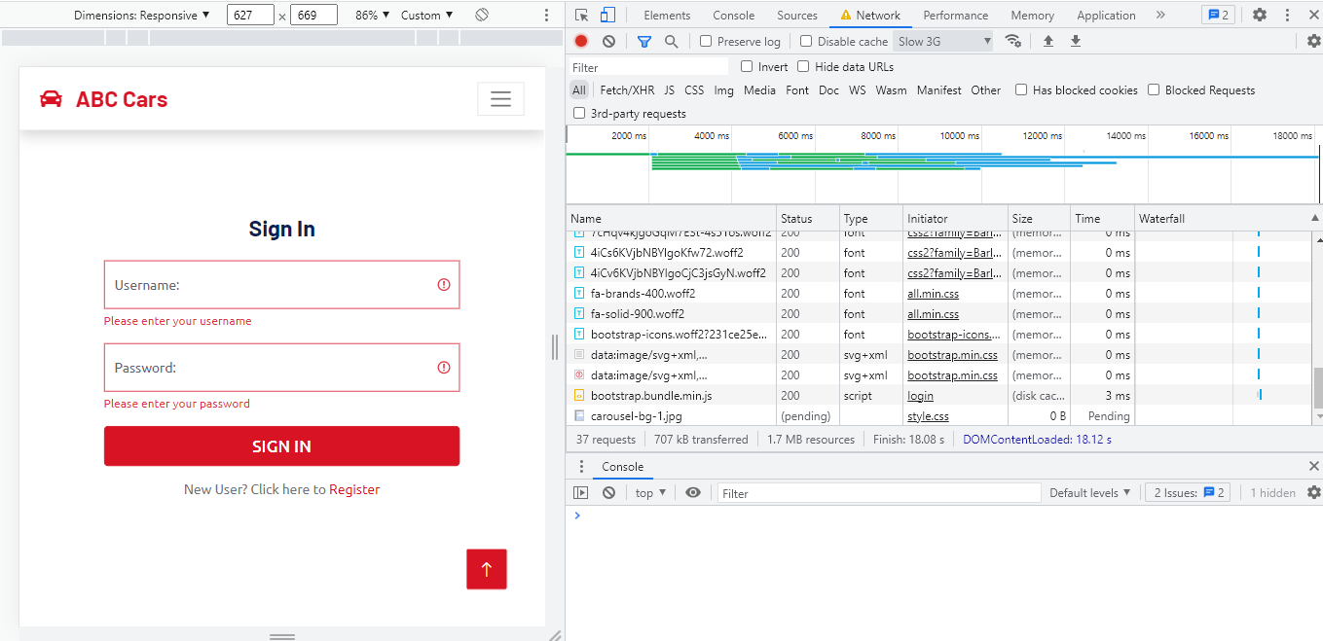

|  |  |  |  |  |  |  |  |  |
| --- | --- | --- | --- | --- | --- | --- | --- | --- |
| PM001 | PMC002 | To check the overall performance of the registration page using Chrome DevTools | Implementation of ABC Car Portal is complete with all webpages and navigation links and uploaded on localhost server | 1. Enter URL localhost:8080 2. Click “Register” on website navigation bar 3. Use Chrome DevTools by right click and choose lighthouse 4. Click ‘Analyze Page Load’ |  | A performance report is generated with performance expected to be above 80 – 90% | As expected, | Pass |

Evidence

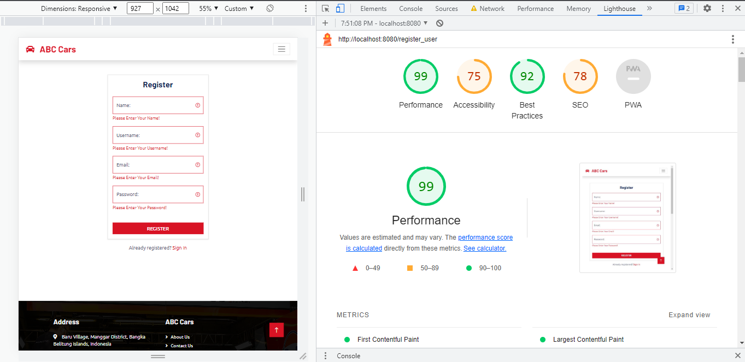

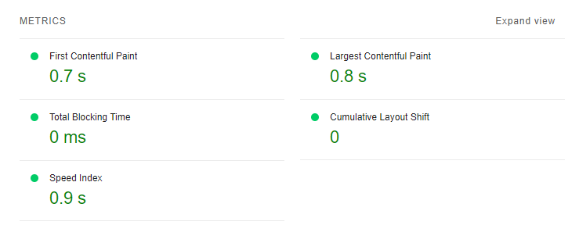

* + 1. Compatibility Testing

|  |  |  |  |
| --- | --- | --- | --- |
| **Requirements** | **Test Scenario ID** | **Test Scenario** | **Number of Test Cases** |
| **Non-Functional Testing** | CB001 – Cross Browser Testing | Ensure register page maintain a consistent look and feel in different browser (Chrome, Edge, Firefox) | 3 |
| CB002 – Cross Browser Testing | Ensure login page maintain a consistent look and feel in different browser (Chrome, Edge, Firefox) | 3 |
| CB003 – Cross Browser Testing | Ensure home page maintain a consistent look and feel in different browser (Chrome, Edge, Firefox) | 3 |
| CB004 – Cross Browser Testing | Ensure car detail page maintain a consistent look and feel in different browser (Chrome, Edge, Firefox) | 3 |
| CB005 – Cross Browser Testing | Ensure profile page maintain a consistent look and feel in different browser (Chrome, Edge, Firefox) | 3 |

|  |  |  |  |  |  |  |  |  |
| --- | --- | --- | --- | --- | --- | --- | --- | --- |
| **Scenario ID** | **Test Case ID** | **Test Case** | **Preconditions** | **Steps** | **Test Data** | **Expected Results** | **Actual Results** | **Pass/Fail** |
| **CB001** | CBCC001 | Check a consistent look and feel of the register page in Google Chrome | Implementation of ABC Car Portal is complete with all webpages and navigation links and uploaded on localhost server | 1. Download ngrok for windows and add authtoken to terminal, enter ngrok http 8080 2. Paste forwarding URL in Lambdatest.com 3. Click ‘Register’ | Forwarding URL  = https://9bea-114-122-83-236.ngrok-free.app/ | After testing,  Register page maintain a consistent look and feel in Google Chrome | As expected, | Pass |

|  |  |  |  |  |  |  |  |  |
| --- | --- | --- | --- | --- | --- | --- | --- | --- |
| **Evidence** |  | | | | | | | |
| CB001 | CBC002 | Check a consistent look and feel of the register page in Firefox | Implementation of ABC Car Portal is complete with all webpages and navigation links and uploaded on localhost server | 1. Download ngrok for windows and add authtoken to terminal, enter ngrok http 8080 2. Paste forwarding URL in Lambdatest.com 3. Click ‘Register’ | Forwarding URL  = https://9bea-114-122-83-236.ngrok-free.app/ | After testing,  Register page maintain a consistent look and feel in Firefox | As expected, | Pass |

|  |  |  |  |  |  |  |  |  |  |  |
| --- | --- | --- | --- | --- | --- | --- | --- | --- | --- | --- |
| Evidence | |  | | | | | | | | |
| CB001 | | CBC003 | Check a consistent look and feel of the register page in Edge | Implementation of ABC Car Portal is complete with all webpages and navigation links and uploaded on localhost server | 1. Download ngrok for windows and add authtoken to terminal, enter ngrok http 8080 2. Paste forwarding URL in Lambdatest.com 3. Click ‘Register’ | Forwarding URL  = https://9bea-114-122-83-236.ngrok-free.app/ | After testing,  Register page maintain a consistent look and feel in Edge | As expected, | Pass | |
| Evidence | |  | | | | | | | | |

|  |  |  |  |  |  |  |  |  |
| --- | --- | --- | --- | --- | --- | --- | --- | --- |
| **Scenario ID** | **Test Case ID** | **Test Case** | **Preconditions** | **Steps** | **Test Data** | **Expected Results** | **Actual Results** | **Pass/Fail** |
| **CB002** | CBCC001 | Check a consistent look and feel of the login page in Google Chrome | Implementation of ABC Car Portal is complete with all webpages and navigation links and uploaded on localhost server | 1. Download ngrok for windows and add authtoken to terminal, enter ngrok http 8080 2. Paste forwarding URL in | Forwarding URL =  https://9bea-114-122-83-236.ngrok-free.app/ | After testing,  Login page maintain a consistent look and  feel in Google | As expected, | Pass |
|  |  |  |  | Lambdatest.com |  | Chrome |  |  |
|  |  |  |  | 3. Click ‘Login’ |  |  |  |  |
| **Evidence** |  | | | | | | | |

|  |  |  |  |  |  |  |  |  |
| --- | --- | --- | --- | --- | --- | --- | --- | --- |
| CB002 | CBC002 | Check a consistent look and feel of the login page in Firefox | Implementation of ABC Car Portal is complete with all webpages and navigation links and uploaded on localhost server | 1. Download ngrok for windows and add authtoken to terminal, enter ngrok http 8080 2. Paste forwarding URL in Lambdatest.com 3. Click ‘Login’ | Forwarding URL =  https://9bea-114-122-83-236.ngrok-free.app/ | After testing,  Login page maintain a consistent look and feel in Firefox | As expected, | Pass |
| Evidence |  | | | | | | | |

|  |  |  |  |  |  |  |  |  |
| --- | --- | --- | --- | --- | --- | --- | --- | --- |
| CB002 | CBC003 | Check a consistent look and feel of the login page in Edge | Implementation of ABC Car Portal is complete with all webpages and navigation links and uploaded on localhost server | 1. Download ngrok for windows and add authtoken to terminal, enter ngrok http 8080 2. Paste forwarding URL in Lambdatest.com 3. Click ‘Login’ | Forwarding URL =  https://9bea-114-122-83-236.ngrok-free.app/ | After testing,  Login page maintain a consistent look and feel in Edge | As expected, | Pass |
| Evidence |  | | | | | | | |

|  |  |  |  |  |  |  |  |  |
| --- | --- | --- | --- | --- | --- | --- | --- | --- |
| **Scenario ID** | **Test Case ID** | **Test Case** | **Preconditions** | **Steps** | **Test Data** | **Expected Results** | **Actual Results** | **Pass/Fail** |
| **CB003** | CBCC001 | Check a consistent look and feel of the home page in Google Chrome | Implementation of ABC Car Portal is complete with all webpages and navigation links and uploaded on localhost server | 1. Download ngrok for windows and add authtoken to terminal, enter ngrok http 8080 2. Paste forwarding | Forwarding URL = <https://9bea-114-122-83-236.ngrok-free.app/>  Username = curry | After testing,  Home page maintain a consistent look  and feel in Google | As expected, | Pass |
|  |  |  |  | URL in Lambdatest.com | Password = curry | Chrome |  |  |
|  |  |  |  | 3. Sign in to the portal |  |  |  |  |
| **Evidence** |  | | | | | | | |

|  |  |  |  |  |  |  |  |  |
| --- | --- | --- | --- | --- | --- | --- | --- | --- |
| CB003 | CBC002 | Check a consistent look and feel of the home page in Firefox | Implementation of ABC Car Portal is complete with all webpages and navigation links and uploaded on localhost server | 1. Download ngrok for windows and add authtoken to terminal, enter ngrok http 8080 2. Paste forwarding URL in Lambdatest.com 3. Sign in to the portal | Forwarding URL = <https://9bea-114-122-83-236.ngrok-free.app/>  Username = curry Password = curry | After testing,  Home page maintain a consistent look and feel in Firefox | As expected, | Pass |
| Evidence |  | | | | | | | |

|  |  |  |  |  |  |  |  |  |
| --- | --- | --- | --- | --- | --- | --- | --- | --- |
| CB003 | CBC003 | Check a consistent look and feel of the home page in Edge | Implementation of ABC Car Portal is complete with all webpages and navigation links and uploaded on localhost server | 1. Download ngrok for windows and add authtoken to terminal, enter ngrok http 8080 2. Paste forwarding URL in Lambdatest.com 3. Sign in to the portal | Forwarding URL = <https://9bea-114-122-83-236.ngrok-free.app/>  Username = curry Password = curry | After testing,  Home page maintain a consistent look and feel in Edge | As expected, | Pass |
| Evidence |  | | | | | | | |

|  |  |  |  |  |  |  |  |  |
| --- | --- | --- | --- | --- | --- | --- | --- | --- |
| **Scenario ID** | **Test Case ID** | **Test Case** | **Preconditions** | **Steps** | **Test Data** | **Expected Results** | **Actual Results** | **Pass/Fail** |
| **CB004** | CBCC001 | Check a consistent look and feel of the car detail page in Google Chrome | Implementation of ABC Car Portal is complete with all webpages and navigation links and uploaded on localhost server | 1. Download ngrok for windows and add authtoken to terminal, enter ngrok http 8080 2. Paste forwarding URL in Lambdatest.com 3. Sign in to the portal, click ‘View Car Details’ | Forwarding URL = <https://9bea-114-122-83-236.ngrok-free.app/>  Username = curry Password = curry | After testing,  Car detail page maintain a consistent look and feel in Google Chrome | As expected, | Pass |
| **Evidence** |  | | | | | | | |

|  |  |  |  |  |  |  |  |  |
| --- | --- | --- | --- | --- | --- | --- | --- | --- |
| CB004 | CBC002 | Check a consistent look and feel of the car detail page in Firefox | Implementation of ABC Car Portal is complete with all webpages and navigation links and uploaded on localhost server | 1. Download ngrok for windows and add authtoken to terminal, enter ngrok http 8080 2. Paste forwarding URL in Lambdatest.com 3. Sign in to the portal, click ‘View Car Details’ | Forwarding URL = https://9bea-114-122-83-236.ngrok-free.app/  Username = curry Password = curry | After testing,  Car detail page maintain a consistent look and feel in Firefox | As expected, | Pass |
| Evidence |  | | | | | | | |

|  |  |  |  |  |  |  |  |  |
| --- | --- | --- | --- | --- | --- | --- | --- | --- |
| CB004 | CBC003 | Check a consistent look and feel of the car detail page in Edge | Implementation of ABC Car Portal is complete with all webpages and navigation links and uploaded on localhost server | 1. Download ngrok for windows and add authtoken to terminal, enter ngrok http 8080 2. Paste forwarding URL in Lambdatest.com 3. Sign in to the portal, click ‘View Car Details’ | Forwarding URL = <https://9bea-114-122-83-236.ngrok-free.app/>  Username = curry Password = curry | After testing,  Car Detail page maintain a consistent look and feel in Edge | As expected, | Pass |
| Evidence |  | | | | | | | |

|  |  |  |  |  |  |  |  |  |
| --- | --- | --- | --- | --- | --- | --- | --- | --- |
| **Scenario ID** | **Test Case ID** | **Test Case** | **Preconditions** | **Steps** | **Test Data** | **Expected Results** | **Actual Results** | **Pass/Fail** |
| **CB005** | CBCC001 | Check a consistent look and feel of the profile page in Google Chrome | Implementation of ABC Car Portal is complete with all webpages and navigation links and uploaded on localhost server | 1. Download ngrok for windows and add authtoken to terminal, enter ngrok http 8080 2. Paste forwarding URL in Lambdatest.com 3. Sign in to the portal, click | Forwarding URL = <https://9bea-114-122-83-236.ngrok-free.app/>  Username = curry  Password = curry | After testing,  Profile page maintain a consistent look and feel in Google Chrome | As expected, | Pass |
|  |  |  |  | ‘Profile’ |  |  |  |  |
| **Evidence** |  | | | | | | | |

|  |  |  |  |  |  |  |  |  |
| --- | --- | --- | --- | --- | --- | --- | --- | --- |
| CB005 | CBC002 | Check a consistent look and feel of the profile page in Firefox | Implementation of ABC Car Portal is complete with all webpages and navigation links and uploaded on localhost server | 1. Download ngrok for windows and add authtoken to terminal, enter ngrok http 8080 2. Paste forwarding URL in Lambdatest.com 3. Sign in to the portal, click ‘Profile’ | Forwarding URL = https://9bea-114-122-83-236.ngrok-free.app/  Username = curry Password = curry | After testing,  Profile page maintain a consistent look and feel in Firefox | As expected, | Pass |
| Evidence |  | | | | | | | |

|  |  |  |  |  |  |  |  |  |
| --- | --- | --- | --- | --- | --- | --- | --- | --- |
|  |  | | | | | | | |
| CB005 | CBC003 | Check a consistent look and feel of the profile page in Edge | Implementation of ABC Car Portal is complete with all webpages and navigation links and uploaded on localhost server | 1. Download ngrok for windows and add authtoken to terminal, enter ngrok http 8080 2. Paste forwarding URL in Lambdatest.com 3. Sign in to the portal, click ‘Profile’ | Forwarding URL = <https://9bea-114-122-83-236.ngrok-free.app/>  Username = curry Password = curry | After testing,  Profile page maintain a consistent look and feel in Edge | As expected, | Pass |
| Evidence |  | | | | | | | |

* + 1. Portability Testing

|  |  |  |  |
| --- | --- | --- | --- |
| **Requirements** | **Test Scenario ID** | **Test Scenario** | **Number of Test Cases** |
| **Non-Functional Testing** | PB001 – Portability Testing | Ensure register page maintain a consistent look and feel in different  devices (laptop, iPad, phone) | 3 |

|  |  |  |  |  |  |  |  |  |
| --- | --- | --- | --- | --- | --- | --- | --- | --- |
| **Scenario ID** | **Test Case ID** | **Test Case** | **Preconditions** | **Steps** | **Test Data** | **Expected Results** | **Actual Results** | **Pass/Fail** |
| **PB001** | PBCC001 | To ensure all feature in the register page is visible to the user in laptop | Implementation of ABC Car Portal is complete with all webpages and navigation links and uploaded on localhost  server | 1. Enter URL localhost:8080 2. navigate to navigation bar 3.Click Register |  | After testing, all register page feature is visible to the user in laptop devices | As expected, | Pass |

|  |  |  |  |  |  |  |  |  |
| --- | --- | --- | --- | --- | --- | --- | --- | --- |
| **Evidence** |  | | | | | | | |
| PB001 | PBC002 | To ensure all feature in the register page is visible to the user in iPad | Implementation of ABC Car Portal is complete with all webpages and navigation links and uploaded on localhost  server | 1. Enter URL localhost:8080 2. navigate to navigation bar 3.Click Register   4.right click choose inspect, Toggle device toolbar |  | After testing, all register page feature is visible to the user in iPad devices | As expected, | Pass |

|  |  |  |  |  |  |  |  |  |
| --- | --- | --- | --- | --- | --- | --- | --- | --- |
| Evidence |  | | | | | | | |
| PB001 | PBC003 | To ensure all feature in the register page is visible to the user in phone | Implementation of ABC Car Portal is complete with all webpages and navigation links and uploaded on localhost  server | 1. Enter URL localhost:8080 2. navigate to navigation bar 3.Click Register   4.right click choose inspect, Toggle device toolbar |  | After testing, all register page feature is visible to the user in phone devices | As expected, | Pass |

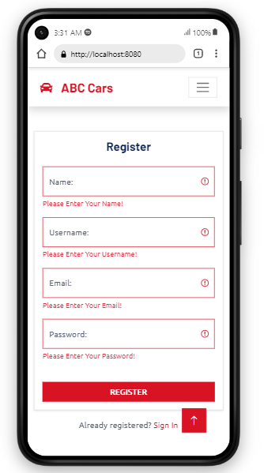Evidence

* + 1. Usability Testing

|  |  |  |  |
| --- | --- | --- | --- |
| **Requirements** | **Test Scenario ID** | **Test Scenario** | **Number of Test Cases** |
| **Functional Testing** | UB001 – Usability Testing | Test whether the register page is user-friendly in design | 1 |
| UB002 – Usability Testing | Test whether the login page is user-friendly in design | 1 |
| UB003 – Usability Testing | Test whether the home page is user-friendly in design | 1 |
| UB004 – Usability Testing | Test whether the car detail page is user-friendly in design | 1 |
| UB005 – Usability Testing | Test whether the profile page is user-friendly in design | 1 |

|  |  |  |  |  |  |  |  |  |
| --- | --- | --- | --- | --- | --- | --- | --- | --- |
| **Scenario ID** | **Test Case ID** | **Test Case** | **Preconditions** | **Steps** | **Test Data** | **Expected Results** | **Actual Results** | **Pass/Fail** |
| **UB001** | UBC001 | Check all navigation in header and footer works properly and the content is visible in register page and user friendliness | Implementation of ABC Car Portal is complete with all webpages and navigation links and uploaded on localhost server | 1. Enter URL localhost:8080 2. Click “Register” on website navigation bar |  | All navigations links is working correctly in the register page and loading the right web pages and having a clear flow easily understood by  user | As expected, | Pass |

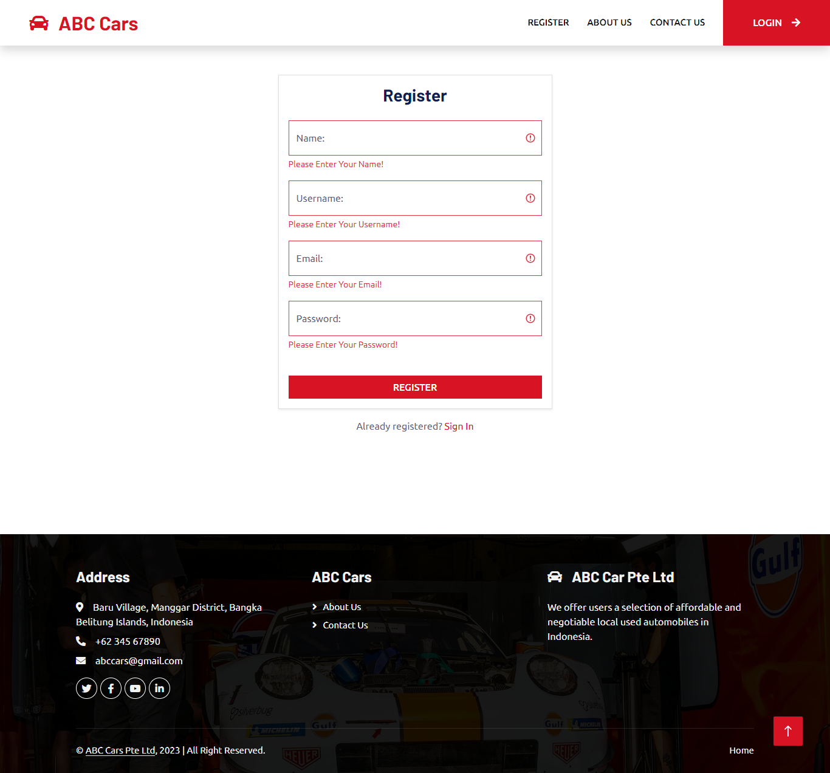**Evidence**

|  |  |  |  |  |  |  |  |  |
| --- | --- | --- | --- | --- | --- | --- | --- | --- |
| **Scenario ID** | **Test Case ID** | **Test Case** | **Preconditions** | **Steps** | **Test Data** | **Expected Results** | **Actual Results** | **Pass/Fail** |
| **UB002** | UBC001 | Check all navigation in header and footer works properly and the  content is visible in login page and user friendliness | Implementation of ABC Car Portal is complete with all webpages and  navigation links and uploaded on localhost server | 1. Enter URL localhost:8080 2. Click ‘Login’ |  | All navigations links is working correctly in the login page and  loading the right web pages and having a clear flow easily  understood by user | As expected, | Pass |

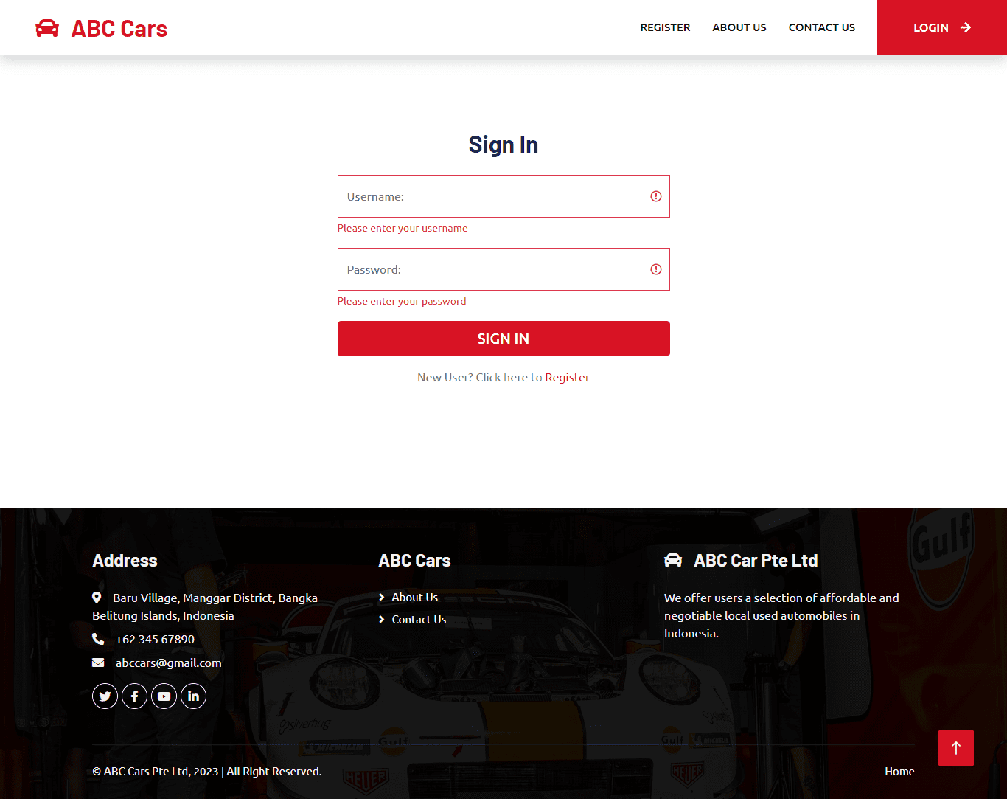

|  |  |  |  |  |  |  |  |  |
| --- | --- | --- | --- | --- | --- | --- | --- | --- |
| **Scenario ID** | **Test Case ID** | **Test Case** | **Preconditions** | **Steps** | **Test Data** | **Expected Results** | **Actual Results** | **Pass/Fail** |
| **UB003** | UBC001 | Check all navigation in header and footer works properly and the content is visible in the home page and user friendliness | Implementation of ABC Car Portal is complete with all webpages and navigation links and uploaded on localhost server | 1. Enter URL localhost:8080  2. Sign in to the portal | Username = curry Password = curry | All navigations links is working correctly in the home page and loading the right web pages and having a clear flow easily understood by user | As expected, | Pass |

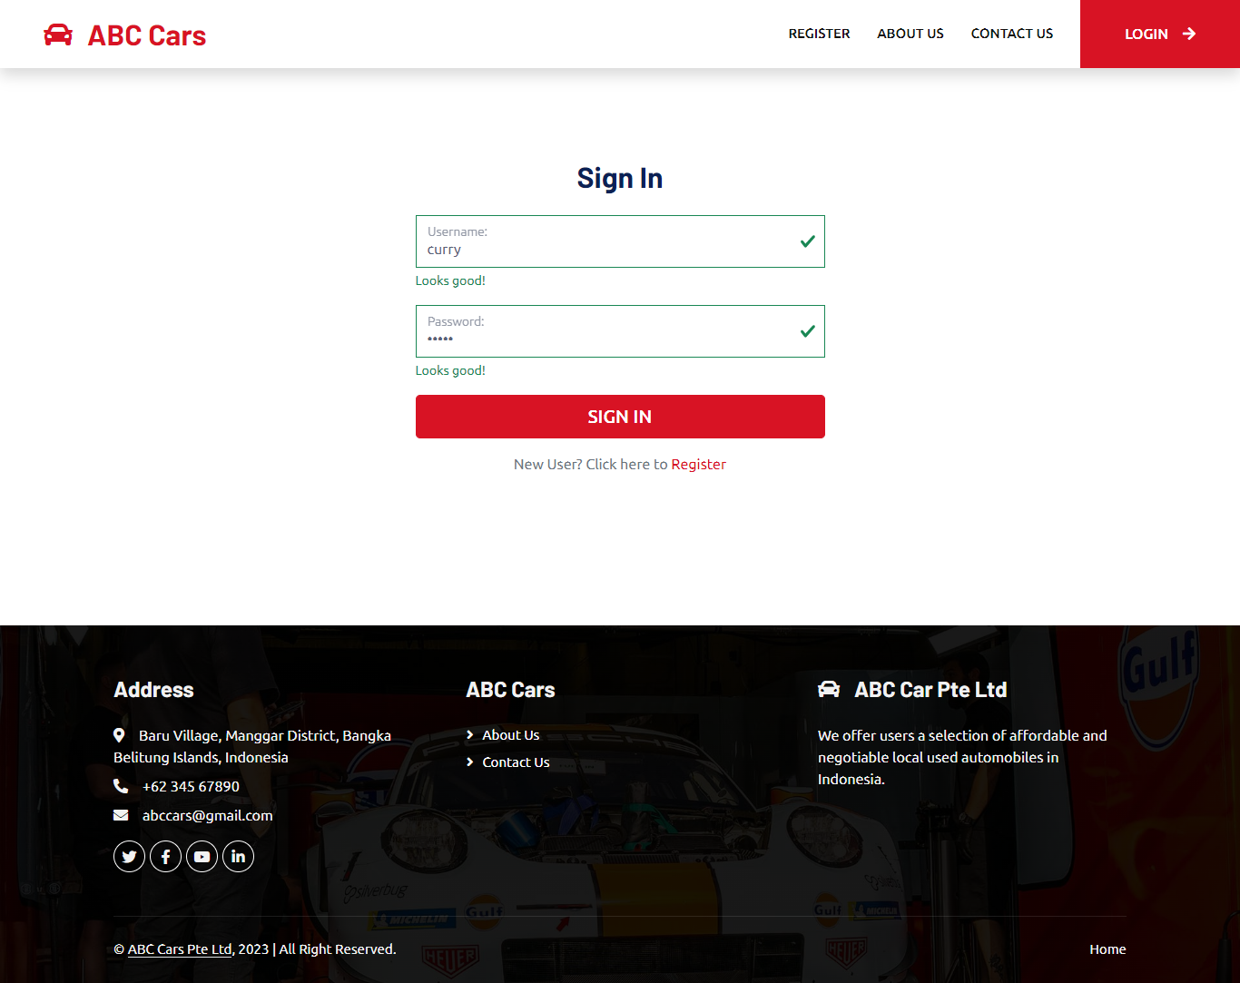**Evidence**

|  |  |  |  |  |  |  |  |  |
| --- | --- | --- | --- | --- | --- | --- | --- | --- |
| **Scenario ID** | **Test Case ID** | **Test Case** | **Preconditions** | **Steps** | **Test Data** | **Expected Results** | **Actual Results** | **Pass/Fail** |
| **UB004** | UBC001 | Check all navigation in header and footer works properly and the content is visible in the car detail page and user friendliness | Implementation of ABC Car Portal is complete with all webpages and navigation links and uploaded on localhost server | 1. Enter URL localhost:8080 2. Sign in to the portal 3. Click View Car details on any car shown in the home   page | Username = curry Password = curry | All navigations links is working correctly in the car detail page and loading the right web pages and having a clear flow easily understood by user | As expected, | Pass |
| **Evidence** |  | | | | | | | |

|  |  |  |  |  |  |  |  |  |  |
| --- | --- | --- | --- | --- | --- | --- | --- | --- | --- |
| **Scenario ID** | **Test Case ID** | **Test Case** | **Preconditions** | **Steps** | **Test Data** |  | **Expected Results** | **Actual Results** | **Pass/Fail** |
| **UB005** | UBC001 | Check all navigation in header and footer works properly and the content is visible in the profile page and user friendliness | Implementation of ABC Car Portal is complete with all webpages and navigation links and uploaded on localhost server | 1. Enter URL localhost:8080 2. Sign in to the portal 3. Navigate to home page navigation bar 4. Click Profile | Username = curry  Password =  curry |  | All navigations links is working correctly in the profile page and loading the right web pages and having a clear flow easily  understood by user | As expected, | Pass |
| **Evidence** |  | | | | | | | | |

* + 1. Security Testing

|  |  |  |  |
| --- | --- | --- | --- |
| **Requirements** | **Test Scenario ID** | **Test Scenario** | **Number of Test Cases** |
| **Functional Testing** | SE001 – Security Testing | Ensure user is authenticated correctly after logging in | 2 |
| SE002 – Security Testing | Ensure after logging in, user home page navigation is authorized correctly based on role assigned | 2 |
| SE003 – Security Testing | Checking for SQL injection | 1 |

|  |  |  |  |  |  |  |  |  |
| --- | --- | --- | --- | --- | --- | --- | --- | --- |
| **Scenario ID** | **Test Case ID** | **Test Case** | **Preconditions** | **Steps** | **Test Data** | **Expected Results** | **Actual Results** | **Pass/Fail** |
| **SE001** | SEC001 | To ensure Spring Security login feature is authenticated correctly for User after login with  valid credentials | Implementation of ABC Car Portal is complete with all webpages and navigation links and uploaded on  localhost server | 1. Enter URL localhost:8080 2. Sign in to the portal | Username = curry Password = curry | User will reach to home page and see option to sell car | As expected, | Pass |
| **Evidence** |  | | | | | | | |

|  |  |  |  |  |  |  |  |  |
| --- | --- | --- | --- | --- | --- | --- | --- | --- |
| **SE001** | SEC002 | To ensure Spring Security login feature is authenticated correctly for User after login with  invalid credentials | Implementation of ABC Car Portal is complete with all webpages and navigation links and uploaded on  localhost server | 1. Enter URL localhost:8080 2. Sign in to the portal | Username = curry  Password = curry123 | User should see an error message asking user to try again  or register | As expected, | Pass |
| **Evidence** |  | | | | | | | |

|  |  |  |  |  |  |  |  |  |
| --- | --- | --- | --- | --- | --- | --- | --- | --- |
| **Scenario ID** | **Test Case ID** | **Test Case** | **Preconditions** | **Steps** | **Test Data** | **Expected Results** | **Actual Results** | **Pass/Fail** |
| **SE002** | SEC001 | To ensure Spring security authorization is working correctly on the navigation bar for user | Implementation of ABC Car Portal is complete with all webpages and navigation links and uploaded on localhost server | 1. Enter URL localhost:8080  2.Sign in to the portal | Username = curry Password = curry | User navigation bar does not show user and car management | As expected, | Pass |

|  |  |  |  |  |  |  |  |  |
| --- | --- | --- | --- | --- | --- | --- | --- | --- |
| **Evidence** |  | | | | | | | |
| **SE002** | SEC002 | To ensure Spring security authorization is working correctly on the navigation bar for  Administrator | Implementation of ABC Car Portal is complete with all webpages and navigation links and uploaded on localhost  server | 1. Enter URL localhost:8080 2. Sign in to the portal | Username = admin Password = admin123 | User navigation bar show user and car management | As expected, | Pass |
| **Evidence** | Only the administrator is allowed to manage the user and all car posted | | | | | | | |

|  |  |  |  |  |  |  |  |  |
| --- | --- | --- | --- | --- | --- | --- | --- | --- |
| **Scenario ID** | **Test Case ID** | **Test Case** | **Preconditions** | **Steps** | **Test Data** | **Expected Results** | **Actual Results** | **Pass/Fail** |
| **SE003** | SEC001 | To ensure search input data is not vulnerable to an SQL injection | Implementation of ABC Car Portal is complete with all webpages and navigation links and uploaded on localhost server | 1. Enter URL localhost:8080 2.Sign in to the portal   1. Navigate to home page navigation bar, search bar 2. Enter search input 3. 5. Click Search | Search input = Select * from car | No return is given as a result from the injected SQL Query | As expected, | Pass |

|  |  |
| --- | --- |
| **Evidence** |  |

**Provide a detailed log of test results**

|  |  |
| --- | --- |
|  | Used Car Sale Portal Project |
|  |  |
| Reported By: | Agung Yuda Pratama |
| Report Date: | 29/04/2023 |
|  |  |
| Tested By: | Agung Yuda Pratama |
| Tested Date: | 29/04/2023 |
| Testing Name/ Test Scenario ID | Functional testing: -Unit Testing/ TS001 / TS002 / TS003 / TS004 /TS005 |
| Total Number of Test Cases | 5 |
| No. of Pass: | 4 |
| No. of Failures: | 1 |
| Elapsed Time: | 00:30:00 |
|  |  |
| Tested By: | Agung Yuda Pratama |
| Tested Date: | 29/04/2023 |
| Testing Name/ Test Scenario ID | Functional testing: -UAT Testing/ UA001 / UA002 / UA003 / UA004 /UA005 |
| Total Number of Test Cases | 10 |
| No. of Pass: | 9 |
| No. of Failures: | 1 |
| Elapsed Time: | 00:30:00 |
|  |  |
| Tested By: | Agung Yuda Pratama |
| Tested Date: | 29/04/2023 |
| Testing Name/ Test Scenario ID | Performance Testing/ PM001 |
| Total Number of Test Cases | 2 |
| No. of Pass: | 2 |
| No. of Failures: | 0 |
| Elapsed Time: | 00:10:00 |
|  |  |
| Tested By: | Agung Yuda Pratama |
| Tested Date: | 29/04/2023 |
| Testing Name/ Test Scenario ID | Compatibility Testing/ CB001 / CB002 / CB003 / CB004 / CB005 |
| Total Number of Test Cases | 15 |
| No. of Pass: | 15 |
| No. of Failures: | 0 |
| Elapsed Time: | 00:40:00 |
|  |  |
| Tested By: | Agung Yuda Pratama |
| Tested Date: | 29/04/2023 |
| Testing Name/ Test Scenario ID | Usability Testing/ UB001/ UB002/UB003/UB004/UB005 |
| Total Number of Test Cases | 5 |
| No. of Pass: | 5 |
| No. of Failures: | 0 |
| Elapsed Time: | 00:20:00 |
|  |  |
| Tested By: | Agung Yuda Pratama |
| Tested Date: | 29/04/2023 |
| Testing Name/ Test Scenario ID | Security Testing/ SE001/ SE002/ SE003 |
| Total Number of Test Cases | 5 |
| No. of Pass: | 5 |
| No. of Failures: | 0 |
| Elapsed Time: | 00:20:00 |
|  |  |
| Tested By: | Agung Yuda Pratama |
| Tested Date: | 29/04/2023 |
| Testing Name/ Test Scenario ID | Portability Testing/ PB001 |
| Total Number of Test Cases | 3 |
| No. of Pass: | 3 |
| No. of Failures: | 0 |
| Elapsed Time: | 00:30:00 |
| SUMMARY LOG STATUS | |
| Total Number of Test Cases | 45 |
| Total Number of Pass | 43 |
| Total Number of Failures | 2 |
| Pass % | 95% |
| Total Elapsed Time | 03:00:00 |

2. Modify the risk-based test procedure with the reasons

According to the log status results, 3 fail result has been recorded. Therefore, the RBT strategy needs to be modified for the abc car portal.

The test plan table are as follows with prioritization on which of the 4 fail test cases are to be retested first after modification.

|  |  |  |  |  |  |  |  |
| --- | --- | --- | --- | --- | --- | --- | --- |
| **Risk ID** | **Test Scenario ID** | **Test Scenario** | **Test Objective** | **Test Priority** | **Risk** | **Technique** | **Expected Results** |
| **1.** | TS001 | Validating registration functionality | To check registered data can be save | High | User will not be able to register  to the portal | Unit Testing | After checking, junit should return a passing  result as user data can be save |

Modification to source code required for each failed test cases:

|  |  |  |
| --- | --- | --- |
| Scenario ID | Test Case ID | Test Case |
| TS001 | TC001 | Check if registered data can be saved    **Before**    **After**    **Result** |
| UA004 | UATC002 | Ensure user can view detail of search car      **Before**    **After**    **Result** |

Log Result after modification

|  |  |
| --- | --- |
| Project ID/ Project Name: | Used Car Sale Portal Project |
|  |  |
| Reported By: | Agung Yuda Pratama |
| Report Date: | 29/04/2023 |
|  |  |
| Tested By: | Agung Yuda Pratama |
| Tested Date: | 29/04/2023 |
| Testing Name/ Test Scenario ID | Functional Testing/ TS001 |
| Total Number of Test Cases | 1 |
| No. of Pass: | 1 |
| No. of Failures: | 0 |
| Elapsed Time: | 00:17:00 |
|  |  |
| Tested By: | Agung Yuda Pratama |
| Tested Date: | 29/04/2023 |
| Testing Name/ Test Scenario ID | UAT Testing/ UA004 |
| Total Number of Test Cases | 1 |
| No. of Pass: | 1 |
| No. of Failures: | 0 |
| Elapsed Time: | 00:17:00 |
|  |  |
| SUMMARY LOG STATUS | |
| Total Number of Test Cases | 2 |
| Total Number of Pass | 2 |
| Total Number of Failures | 0 |
| Pass % | 100% |
| Total Elapsed Time | 00:17:00 |

**Task 7**

Create the following items under **“Evaluation of Testing strategy”** in Project Presentation.

1. Evaluate the effectiveness of the RBT strategy and assess the security testing cycles

2. Evaluate the testing strategies and compare it’s pro and cons

3. Assess the importance and environment suitability and examine the test heuristics are identified with proper justification

**1. Evaluate the effectiveness of the RBT strategy and assess the security testing cycles.**

Various stages of the software development life cycle (SDLC), including the spiral model, have seen success with risk-based testing. Implementing RBT simplifies finding application flaws that can cause significant problems after deployment. Finding faults after deployment is more expensive than identifying potential dangers early on. Depending on their seriousness, a risk matrix can be used to classify the discovered dangers as low, moderate, high, or extreme. Testing is prioritized for the dangers that are high and extreme. After that, test cases are created and run; if any fail, a mitigation strategy is implemented before further tests are conducted.

The cycle continues until all major risk factors have been completely eliminated or kept at the bare minimum. Every level of the SDLC model requires security testing, and security is regarded as a non-functional requirement throughout the requirement stage. The car portal should be created with confidentiality and integrity to guard against cyberattacks that could lead to data misuse. Authentication, authorization, and defense against frequent attacks like SQL injection are all provided by Spring Security. A user's identity is confirmed using their registered credentials in the database, which is how authentication is tested.

Authorization is used to segregate tasks based on assigned roles. To test for SQL injection attacks, an SQL query was inserted into the input field for searching. Input validation can prevent SQL injection attacks by sanitizing input data from malicious code elements like single quotes.

**2. Evaluate the testing strategies and compare it’s pro and cons**

The leaner needs to evaluate testing strategies that used in car portal and compare their pro and cons.

|  |  |
| --- | --- |
| **Before Using RBT** | |
| **Pro** | **Cons** |
| * Efficient testing | * May overlook low-risk areas |
| * Effective risk mitigation | * Can be time-consuming |
| * Cost-effective | * Requires expertise |

**3. Assess the importance and environment suitability and examine the test heuristics are identified with proper justification**

|  |  |
| --- | --- |
| **Environment** | **The Importance of Environment Suitability and How It Supports RBT Test Strategy** |
| STS IDE | The Spring Tool Suite is an IDE for developing Spring Boot applications like the ABC Car Portal. Spring Boot allows for features such as dependency injection to be implemented and a vital capability for managing database transactions. Unit testing can also be carried out within this IDE using JUnit, which can be included in the build path for the car portal project. Furthermore, the Spring Boot Test, a maven dependency injected for conducting unit tests, provides support for mocking. This allows the main focus to be on the code being tested rather than external dependencies or behavior. |
| MySQL Database | The user, car, car bidding, and user role information are all stored in distinct tables using the MySQL database. It is also one of the most secure databases, with features like user authentication, encryption, and a firewall. A user's password is encrypted and saved in the database when registering for the portal, ensuring high data security. |
| Window 10 OS | Windows 10 Is currently OS used in this device to install all the software required to develop ABC Cars Pte Ltd |
| Java Version 8 | The Java programming language is used to create the car portal. Access modifiers like "private" can be used in Java's security feature to restrict access to fields, functions, and classes. The POJO class's fields are configured as private in the case of the automobile gateway, making getter and setter methods necessary to access them. Additionally, Java provides automatic memory management, removing the need for developers to manage garbage collection-based memory manually. |
| ABC Cars Pte Ltd  (Used Car Sales Portal Application) | The customer's requirements must be followed, and the creation of the ABC Car Portal must be finished in a certain amount of time. Its functional and non-functional needs must be tested to ensure its quality. Unit testing, user acceptance testing (UAT), performance testing, compatibility testing, portability testing, usability testing, and security testing are some of the tests performed. |
| Test Plan | The amount of risk detected by the Risk Matrix determines the priority of the test plan. Priority is given to high-risk regions, also noted in a test log. Whenever a test case fails, it will be retested when the issues have been mitigated. This procedure ensures that the danger is always checked and that the automobile portal application's quality is upheld. |
| Documentation | The automobile portal application records the results of several test types, such as unit testing, user acceptance testing (UAT), performance testing, compatibility testing, portability testing, usability testing, and security testing. Any failed test cases can be found by documenting these tests, and the risk level can then be evaluated to decide which parts need to be retested. |
| Devices | Three devices—a laptop, iPad, tablet, or mobile phone—were used to assess the automobile website's adaptability to various hardware elements. Portability testing was carried out by selecting the Toggle Device toolbar in Chrome DevTools. |
| Browsers | For cross-browser testing on the Lambdatest website, three different browsers—Chrome, Edge, and Firefox—were employed. The goal was to provide a consistent visual and tactile experience across browsers for the car portal. Additionally, Google Chrome, the most popular browser, has tools like Chrome DevTools, where performance testing may be done to determine the automobile portal's overall performance and loading time using Lighthouse. Research for the car portal's documentation was also done using Chrome. |

**Task 8**

1. **Provide screen capture of developed pages** and hosted applications in Project Presentation
   1. login.jsp



* 1. Register.jsp



* 1. aboutUs.jsp

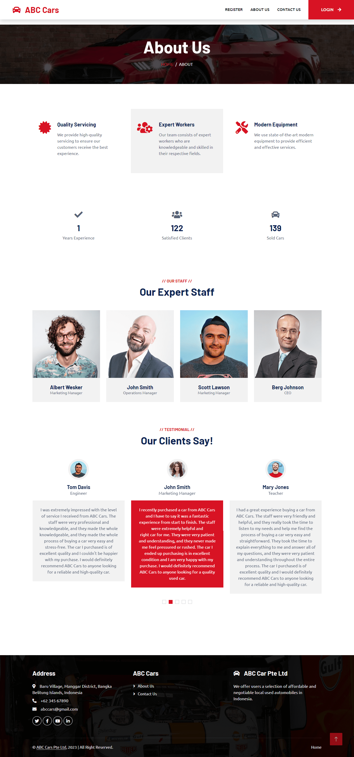

* 1. contactUs.jsp

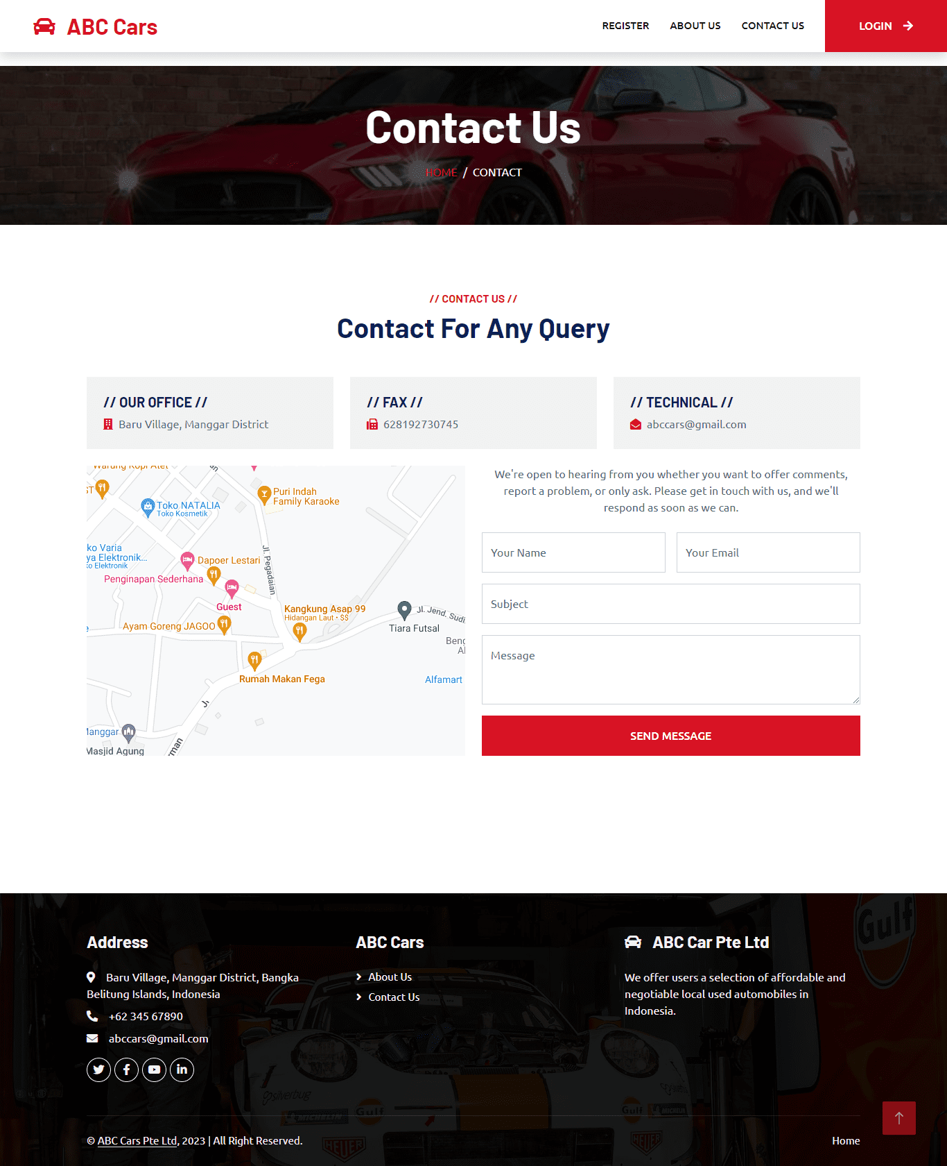

* 1. viewCars.jsp (user)

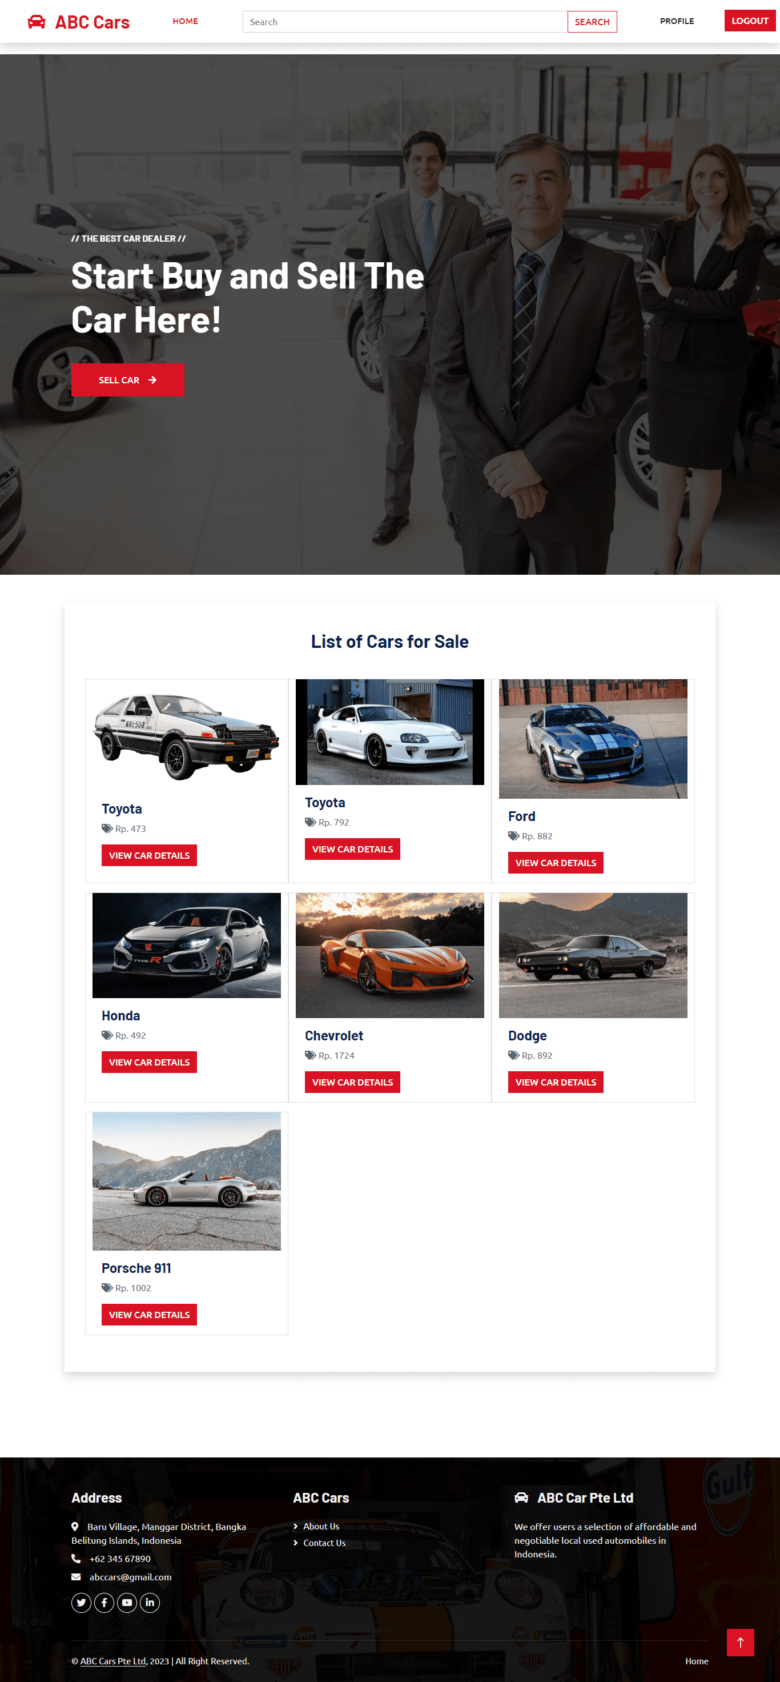

* 1. viewCars.jsp (admin)

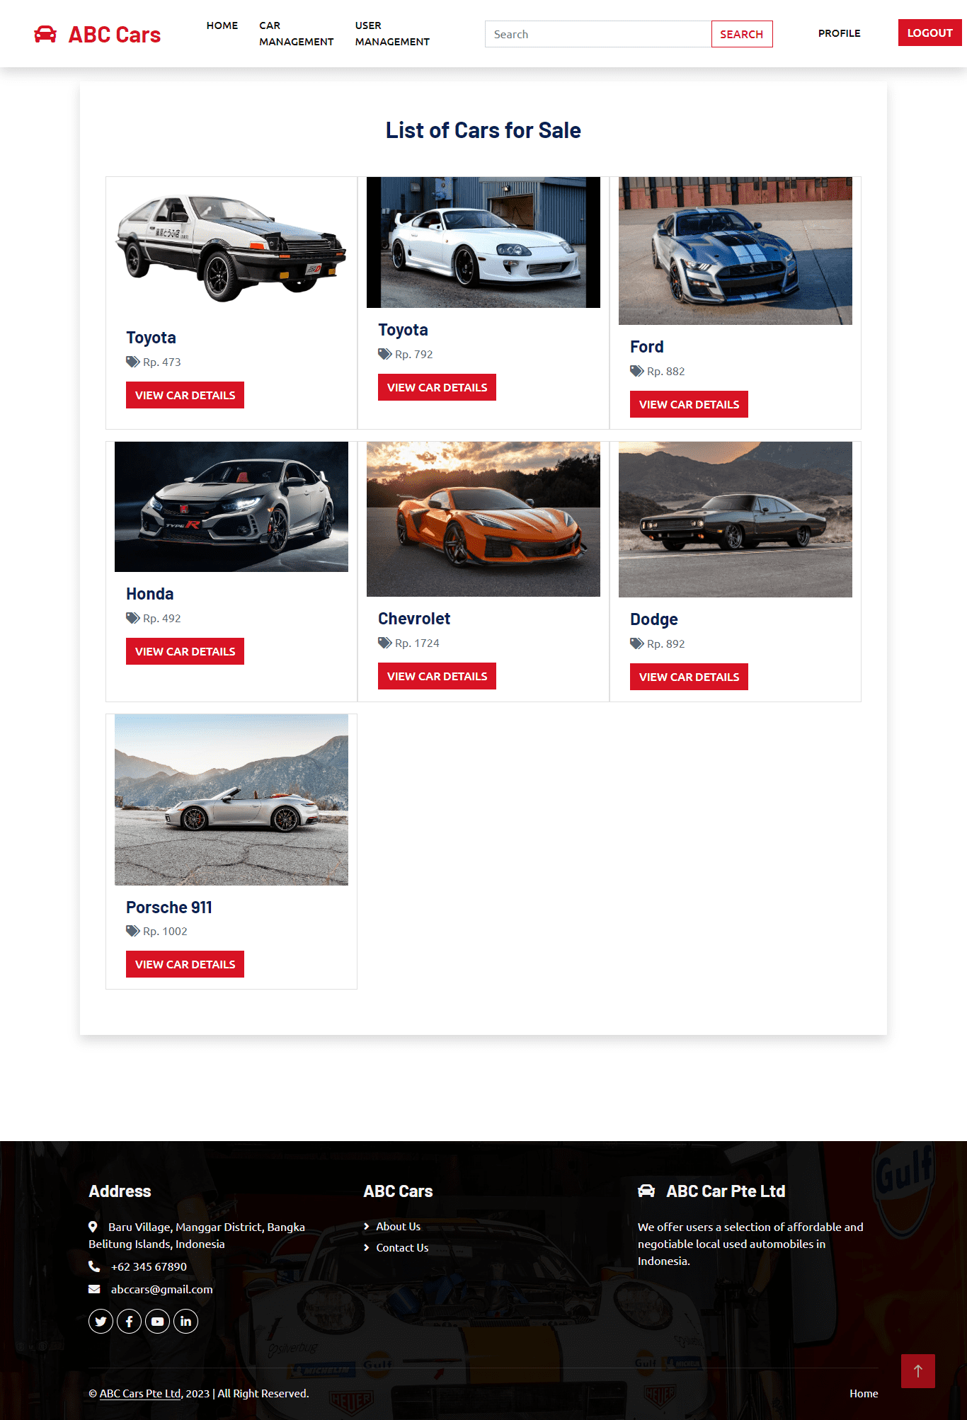

* 1. carDetail.jsp

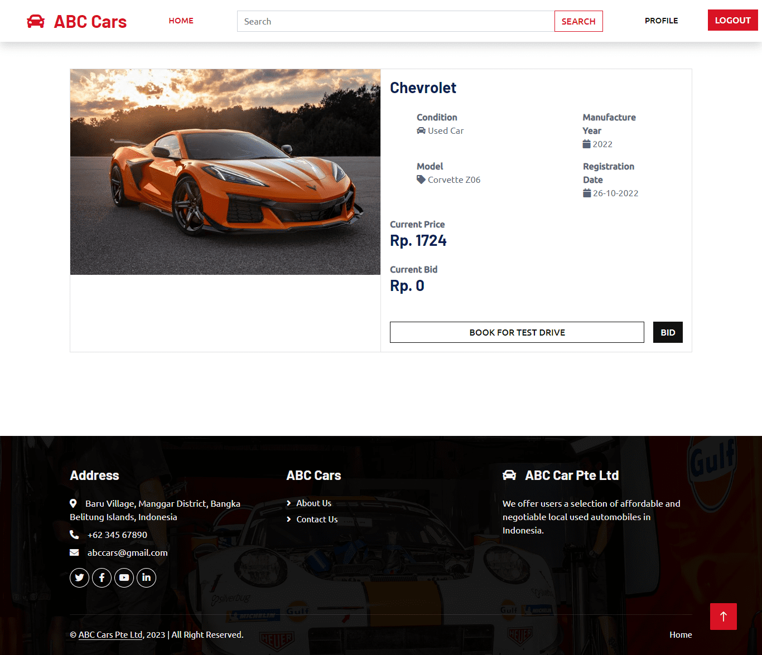

* 1. profile.jsp

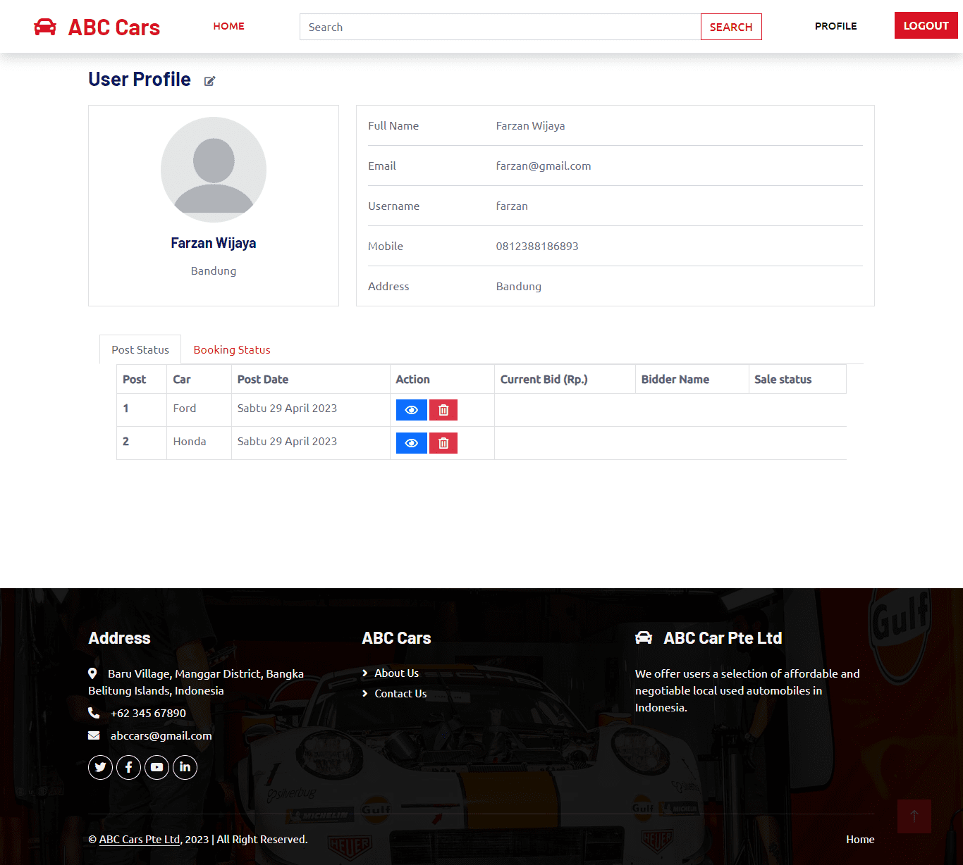

* 1. searchResults.jsp

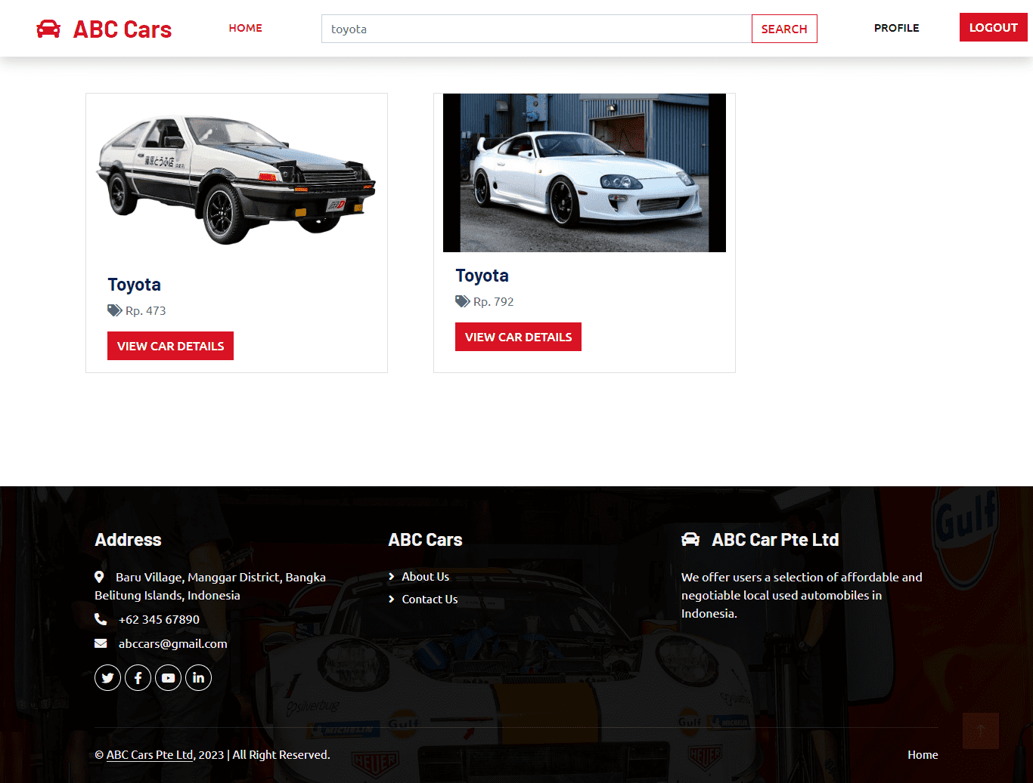

* 1. allCar.jsp (admin)

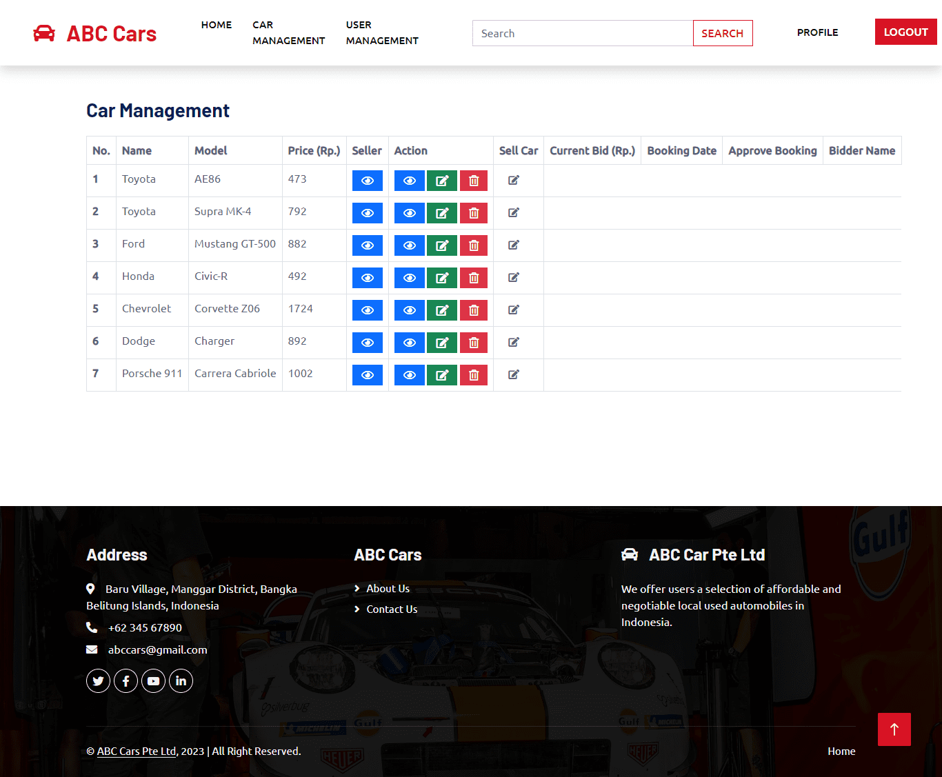

* 1. allUser.jsp (admin)

